**BALANCING BOOKS AND BALLS: A QUANTITATIVE STUDY ON STUDY HABITS AND ACADEMIC PERFORMANCE OF VOLLEYBALL AND BASKETBALL STUDENT ATHLETES**

A Research paper presented to the faculty of

King Thomas Learning Academy, Inc.

Malubago, Sipocot, Camarines Sur.

In partial fulfillment of the requirements for the

subject Practical Research II

GENERAL ACADEMIC STRAND

**CALAYO, KRISTIAN PAUL F.**

**COLLANTES, RONALYN A.**

**GACER, JEFFRYZEN F.**

**RAVAGO, JAYRON R.**

**PALENZUELA, IAN B.**

**PEREJA, KATE ANN P.**

December 2024

**CERTIFICATE OF APPROVAL**

The research paper attached hereto, titled **“BALANCING BOOKS AND BALLS: A QUANTITATIVE STUDY ON STUDY HABITS AND ACADEMIC PERFORMANCE OF VOLLEYBALL AND BASKETBALL STUDENT-ATHLETES”** prepared and submitted by **CALAYO, KRISTIAN PAUL F., COLLANTES, RONALYN A., GACER, JEFFRYZEN F., RAVAGO, JAYRON R., PALENZUELA, IAN B., PEREJA. KATE ANN P.** In partial fulfillment of the requirements for the subject, Practical Research II is hereby accepted and approved by the Board of Panel whose signature appears below.

**EVELYN D. ATCHERO JAHZIEL A. MALAA**

Panel Member Panel Member

**MELANIE ROSE SJ. REYES**

Panel Member

**STEPHANIE T. HUERTE**

Research Adviser

**MARY JOYCE N. RAMOS**

Senior High School Assistant Principal

**ANGELI P. MORADA**

Senior High School Principal

**ACKNOWLEDGEMENT**

The researchers would like to convey their immense gratitude to everyone who so kindly assisted during the course of our research. For their willingness to assist, their constant and steadfast support, their encouragement, their financial support, and most importantly, their time.

We extend our deepest gratitude to our research adviser, **Ma’am Stephanie T. Huerte**, for her steadfast support, profound insights, and exceptional guidance throughout the course of our research titled **“BALANCING BOOKS AND BALLS: A QUANTITATIVE STUDY ON STUDY HABITS AND ACADEMIC PERFORMANCE OF VOLLEYBALL AND BASKETBALL STUDENT-ATHLETES”**. Your mentorship has been instrumental in shaping our comprehension of the research process and has greatly contributed to the success of this study.

Your expertise and encouragement have been invaluable, consistently supporting us through each stage of our research journey. The constructive feedback and thorough critiques you provided have been fundamental in refining our work and fostering our intellectual growth. Additionally, we would like to acknowledge and sincerely thank you for your assistance with the statistical computations, which were critical to the integrity and accuracy of our findings.

Without your unwavering support and dedication, this research would not have reached its full potential, and for that, we are profoundly grateful. Your commitment to our development has inspired us to achieve excellence in all aspects of our work. Thank you for being an exemplary mentor and for your significant contributions to our quantitative research journey.

The researchers would also like to extend their profound gratitude to the distinguished panelists, **Ma’am Stephanie T. Huerte, Ma’am Melanie Rose SJ. Reyes, Ma’am Evelyn D. Atchero, and Ma’am Jahziel A. Maala**, for their generous dedication of time, expertise, and invaluable insights during the defense of our research project. Their thoughtful questions, constructive feedback, and expert contributions have been instrumental in refining our arguments, enhancing our methodology, and deepening our understanding of the subject matter.

The expertise and guidance provided by the esteemed panelists have not only enriched our research but have also significantly elevated the quality and rigor of our work. Their invaluable contributions have undoubtedly enriched the outcome of our research. Furthermore, we are deeply appreciative of the additional support they provided, including the thorough review of our statistical computations, which ensured the accuracy and reliability of our findings. The mentorship and support from these esteemed individuals have been pivotal in our academic journey, and we are sincerely thankful for their unwavering commitment to our success. Their dedication to fostering our intellectual growth and encouraging excellence has been a source of inspiration throughout the outcome of this research.

The researchers also would like to thank the individuals who graciously granted us permission to conduct our survey among the selected respondents for our study. Your cooperation and support have been invaluable in facilitating the smooth execution of our research. Furthermore, we wish to express our sincere appreciation to the adviser of the respondents for providing us with the necessary 1st semester midterm grades of the volleyball and basketball student-athletes. Your willingness to share this information has significantly contributed to the success and completeness of our research.

To my fellow groupmates for their significant contributions. Everybody’s commitment, knowledge, and work were vital to the accomplishment of our research. Our collaborative effort, dedication, and energy have been the driving force behind the success of our research project. Each of you has brought unique perspectives, talents, and strengths to the table, and together, we have navigated the complexities of the research process with resilience, creativity, and mutual support. Our unwavering commitment to excellence, professionalism, and teamwork has been truly inspiring, and we are immensely grateful. All of your efforts and cooperation are appreciated.

Lastly, we would like to express our appreciation to all those who have supported us in ways both seen and unseen-our families, friends, and colleagues-who have provided encouragement, understanding, and unwavering support throughout this research journey. Your belief in our abilities and your encouragement during moments of doubt have been a source of strength and motivation, and deeply appreciative of your help and for your unwavering support.

**K.P.F.C**

**R.A.C**

**J.F.G**

**I.B.P**

**K.A.P.P**

**BALANCING BOOKS AND BALLS: A QUANTITATIVE STUDY ON STUDY HABITS AND ACADEMIC PERFORMANCE OF VOLLEYBALL AND BASKETBALL STUDENT-ATHLETES**

**Abstract**

This study investigates the study habits and academic performance of volleyball and basketball student-athletes. The research aims to understand their study habits concerning time management, active learning, and environmental control, and to determine if there is a significant relationship between these habits and their academic performance. Data from 47 respondents revealed that the highest indicators of effective study habits included managing time between training and academics, having necessary supplies for studying, and preferring quiet study environments. Conversely, less effective habits included not setting personal deadlines and not highlighting key points while studying. Among the study habits is environmental control were ranked first, second is active learning, and third is time management. In terms of academic performance, most student-athletes performed satisfactorily, with only a small percentage achieving outstanding grades. The study found that the relationship between time management and academic performance was not significant, while there was a very low negative correlation between active learning, environmental control, and academic performance. These findings suggest that other factors might be more influential in determining the academic success of student-athletes. The study concludes that volleyball and basketball student-athletes have effective study habits but balancing dual roles might require further support to enhance their academic achievements.

*Keywords:* ***Study Habits, Academic Performance, Student Athletes, Time Management, Active Learning, and Environmental Control***

|  |  |
| --- | --- |
| **TABLE OF CONTENTS** | |
| **Preliminaries** | |
| **Title Page** |  |
| Certificate of Approval | i |
| Acknowledgment | ii |
| Abstract | v |
| Table of Contents | vi |
| List of Tables | viii |
| List of Figures | ix |
| List of Appendices | x |
| **Chapter I. Introduction** |  |
| Statement of the Problem | 2 |
| Objectives of the Study | 3 |
| Scope and Limitations | 3 |
| Significance of the Study | 3 |
| **Chapter II. Review of Related Literature and Studies** |  |
| Review of Related Literature | 6 |
| Review of Related Studies | 8 |
| Synthesis | 10 |
| Theoretical Paradigm | 14 |
| Conceptual Paradigm | 15 |
| Definition of Terms | 17 |
| Assumptions of the Study | 18 |
| Hypothesis | 18 |
| **Chapter III. Methodology** |  |
| Research Design | 19 |
| Research Setting | 19 |
| Respondents | 19 |
| Research Instrument | 20 |
| Validity and Reliability | 20 |
| Data Gathering Procedure | 20 |
| Statistical Treatment | 21 |
| **Chapter IV. Results and Discussion** |  |
| Study Habits of Volleyball and Basketball  Athletes in terms of Time Management,  Active Learning, and Environmental Control | 22 |
| Academic Performance of Volleyball and  Basketball Student Athletes | 30 |
| Significant Relationship between the  Study Habits and Academic Performance  of Volleyball and Basketball Student Athletes | 32 |
| **Chapter V. Summary, Findings, and Conclusions** |  |
| Problem 1. What are the Study Habits of Volleyball  and Basketball Student-Athletes in terms  of Time Management, Active Learning,  Environmental Control | 36 |
| Problem 2. What is the Academic Performance  Of Volleyball and Basketball Student Athletes. | 41 |
| Problem 3. Is there any significant relationship  between the Study Habits and Academic  Performance of Volleyball and Basketball  Student-Athletes. | 42 |

|  |  |  |
| --- | --- | --- |
|  | **LIST OF TABLES** |  |
| **Table 1** | The Study Habits of Volleyball and Basketball  Student Athletes in terms of Time Management. | 23 |
| **Table 2** | The Study Habits of Volleyball and Basketball  Student Athletes in terms of Active Learning. | 25 |
| **Table 3** | The Study Habits of Volleyball and Basketball  Student Athletes in terms of Environmental Control. | 26 |
| **Table 4** | Summary of the Study Habits of Volleyball and Basketball Student Athletes. | 27 |
| **Table 5** | Academic Performance of Volleyball and Basketball  Student Athletes in First Semester Midterm  Grading Period. | 31 |
| **Table 6** | Relationship between the Study Habits and Academic Performance of Volleyball and Basketball Student Athletes. | 33 |
|  |  |  |

|  |  |  |
| --- | --- | --- |
|  | **LIST OF FIGURES** |  |
| **Figure 1** | Theoretical Framework | 12 |
| **Figures 2** | Conceptual Framework | 16 |
|  |  |  |
|  |  |  |
|  |  |  |

|  |  |  |
| --- | --- | --- |
|  | **LIST OF APPENDICES** |  |
| **APPENDIX** |  | |
| **A** | References | xliv |
| **B** | Approval Sheets | xlvii |
| **C** | Sample Questionnaire | lxxv |
| **D** | Statistical Computation | lxxv |
| **E** | Curriculum Vitae | lxxxv |

**CHAPTER I**

**INTRODUCTION**

In the field of school sports programs, student-athletes face unique challenges in balancing their academic responsibilities with the demand of their athletic pursuits. There are numerous student athletes in different fields of school sports. Amongst these student athletes, volleyball and basketball student athletes are known for their exceptional agility on the court as well as their dedication to their studies off the court.

Volleyball and basketball are two of the sports in schools and in universities. The dynamic nature of being involve in volleyball and basketball sports foster an environment where student athlete must navigate academic challenges alongside the rigors of competitive sports. The ability to handle intense training sessions, competitive games, and challenging academic work are the skills that many student athletes develop over time. According to Steele et. al, (2020), many students have developed strategies to mitigate conflict between their academic and athletic roles. Successful implementation of these strategies was deemed beneficial to one’s well-being, with achieving a balance between academic and athletic becoming easier to obtain with greater life experiences of a student. However, conflicting results suggest that Student-Athletes were not always successful in balancing multiple roles demands, with the full-scheduled cited as a major barrier to successfully engaging in dual careers, often resulting in avoidance related coping strategies, such as disengagement from study or failure to attend mandatory classes that often cause a stressor for student athletes. Being a volleyball and basketball student athletes can seem to inherently contradict academic success. With so much time and effort spent on athletics, academic rigors can be unnecessary extra stressors to student-athletes. The pressure of winning a game in sports also conflicts with the scheduled time of studies and motivation to achieve high grades.

In examining the experiences of volleyball and basketball student-athletes, this study sought to understand the strategies and coping mechanisms employed by student-athletes to navigate the challenges of academic rigors and competitive sports. Through a quantitative exploration of the study habits and academic performance of volleyball and basketball student athletes, this research aimed to contribute to a deeper understanding of the complex yet rewarding journey of balancing books and balls.

**Statement of the Problem**

This study aimed to answer the following questions about Balancing Books and Balls: A Quantitative study on Study Habits and Academic Performance of Volleyball and Basketball Student-Athletes. Specifically, it sought to answer the following questions:

1. What are the study habits of volleyball and basketball student-athletes in terms of:
   1. Time Management
   2. Active Learning
   3. Environmental Control
2. What is the academic performance of the volleyball and basketball student athletes?
3. Is there any significant relationship between the study habits and the academic performance of volleyball and basketball student athletes?

**Objectives of the Study**

The following objectives will guide the study:

1. Identify the study habits of basketball athletes in terms of time management, active learning, and environmental control.
2. Determine the academic performance of the volleyball and basketball student athletes.
3. Evaluate the significant relationship between the study habits and academic performance of volleyball and basketball student athletes.

**Scope and Limitations**

The scope of this study focused on study habits and academic performance of volleyball and basketball student athletes only, other sports were not included in this study. This study was limited to the academic performance of volleyball and basketball student athletes on their 1st semester midterm grades, in the academic year 2024-2025. The respondents of this study were the volleyball and basketball student athletes of King Thomas Learning Academy Inc. regardless of their year level.

**Significance of the Study**

This paper would be beneficial to various audiences, including:

**Student-Athletes.** This study will help the students who are involved in sports to be aware of what are the effective study habits that will help them in their academic performance.

**Teachers.** This study will help the teachers to monitor the academic progress of volleyball and basketball student athletes, provide extra support when needed, and coordinate with coaches to accommodate practice and game schedules.

**Parents and Guardians.** This study will benefit the role of parents and guardians in supporting the academic and athletic development of volleyball and basketball student athletes. In the way of providing guidance, encouragement, and a supportive environment at home, parents can help student-athletes manage their commitments and achieve success both academically and in sports.

**Coaches and Trainers.** This study can provide benefits to the volleyball and basketball coaches and athletic trainers who work closely with student-athletes to optimize their performance on the court. Coaches can also play a role in promoting academic success by encouraging time management, fostering a culture of academic excellence, and providing guidance on balancing sports and studies.

**Department of Education (DepEd):** This study will benefit the Department of Education (DepEd) to understand the unique challenges faced by student-athletes and develop tailored support programs to enhance their academic success. Through examining the academic performance of basketball athletes, DepEd can gain knowledge on how to promote academic-athletic balance, design effective support programs, and strengthen collaborations between educational and sports departments for the benefit of student-athletes’ overall development.

**Department Heads.** This will benefit the Deans or heads of the different Departments to collaborate with coaches and athletic staff to ensure that volleyball and basketball student athletes receive the necessary academic support, proper scheduling, and accommodations to thrive in their studies while pursuing their athletic goals.

**Non-athletic Students.** This study will help non-athletic students who want to be part of volleyball and basketball student athletes to be aware of how to balance their passion for sports and manage their academic performance.

**Future Researchers.** This study will benefit future researchers for this will serve as their reference materials for the study related to volleyball and basketball and their academic performance.

**CHAPTER II**

**REVIEW OF RELATED LITERATURE AND STUDIES**

This paper introduced and presented a review of related literature and studies bearing on the present pursuit of knowledge. The clear understanding and ideas procured from this review provided the researchers with useful and worthy insight to support the study.

**Review of Related Literature**

Castro (2024) stated that study habits refer to the student athletes’ way of carrying out the task of studying by using various techniques and ways in the field of study to keep students afloat along with the wise use of his/her time in studying. Whether the study habits are systematic or unsystematic there could always be an impact to student-athletes academic performance. Since the learning factor that extremely influences student academic achievements is study habits, establishing its foundation regardless of the student's level of education is very important because it aids him/her in increasing their capability to be a self-directed and self-disciplined student. When student-athletes have established good study habits, the athletes would expect to be less stressed and less worried during exam day, thus students who also organize and adhere to their established study progress are more confident and appear at test-taking time and yield better grades.

Hill (2023) highlights the importance of a balanced approach by universities, emphasizing both athletic and academic commitments. Student-athletes have showcased academic achievement successfully and showcased that even if the athletes are facing dual roles the student-athletes can also pass academic work. Factors such as discipline, time management, study habits and strategies, and the structure provided within athletic programs have been identified as potential catalysts for these positive outcomes. The aim is to ensure academic success regarding grades and foster an environment where Student-Athletes can engage in meaningful academic and extracurricular pursuit

Steele et. al, (2020) Stated that many students have developed strategies to mitigate conflicts between their academic and athletic roles, such as enhancing role convergence, time prioritization and management, study habits, and social and family support. Successful implementation of these strategies was deemed beneficial to one’s well-being, with achieving a balance between academic and athletic becoming easier to obtain with greater life experiences of a student. However, conflicting results suggest that Student-Athletes were not always successful in balancing multiple roles and demands, with the full-scheduled cited as a major barrier to successfully engaging in dual careers, often resulting in avoidance-related coping strategies, such as disengagement from study or failure to attend mandatory classes that often cause a stressor for student-athletes.

According to Sharma and Vyas (2017), study habits can be classified into two good study habits and poor study habits. Good study habits can be defined as having good quality time, being organized, reading textbooks as well as studying at the same time each day. Learning to listen to anything discussed and remembering details are important beginnings of developing good study habits. Good study habits include many different skills: time management, concentration, memorization, and reviewing. Poor study habits include cutting class, not doing academic work or tasks, and not giving full in-class discussions. In general terms, study habits are the application of mental faculties to acquire knowledge and better academic performance.

Cosh and Tully (2014) found that good time management skills are positively correlated with the both academic and athletic performance of student athletes. Time management skills such as able to make personalized planning, schedule, and taking in consideration of the student academic deadlines and training schedules to guarantee that the student had the ability to navigate their responsibilities. The study also propose that the student developed the ability to “flexible focus” in other words, student who can quickly switch to their attention between learning and training tend to perform better. It is recommended that student athletes practice the ability to quickly switch task by making detailed daily plans. It also analyzed that time management is essential to success of student athletes.

**Review of Related Studies**

According to the study of Sinocruz and Daing (2022) students who are involved in school extra-curricular activities accomplish better at school. However, some of the student athletes are having a hard time emerging with academic performances, but still manage to obtain a passing grade. The student-athletes claimed that student-athletes are not able to prepare for tests and academic tasks because much of student-athletes attention is in training outside the classroom. Being absent in class, not paying full attention, and not listening to teachers’ comments about tests and other academic tasks are some of the factors. The student-athletes are not expected to make efforts in taking tests since students involved in sports, and athletes are considered during major examinations. The student-athletes usually miss important information about the preparation for tests simply because much of the athletes’ time is outside the classroom. This study revealed that the perception of student-athletes on the different study habits can help to accomplish academic performances, however, some student athletes are having difficulties accomplishing the academic task, but with the help of the consideration of teachers, the student athletes can still manage to obtain a passing grade.

Anggiani & Heryanto (2018) conducted a study exploring student preferences for informal learning spaces on campus. The study concluded that students generally preferred to study in environments that were comfortable, quiet, clean, safe, and strategically located. These preferences highlight the importance of creating well-designed, organized study areas that cater to students’ needs. The study also emphasized the importance of creating a positive atmosphere in educational settings, as it can enhance students’ motivation and engagement, leading to better academic outcomes. The study suggested that providing such spaces could significantly enhance students’ learning experiences and academic performance by offering them a conducive environment for both focused study and collaborative learning.

The study by Atsiaya and Maiyo (2015) explores the relationship between study habits and academic achievement among students. The findings revealed that study habits do play a role in academic success, but study habits are not the only determining factor. The study suggests that other variables, such as teaching quality, student motivation, and family support, also significantly impact academic performance. Additionally, the study highlights that both teachers and students need to put more effort into developing effective study habits. The overall impact of study habits on academic achievement was not overwhelmingly strong, suggesting that a holistic approach considering multiple factors is necessary to improve student performance. This underscores the importance of addressing various aspects of the educational environment to foster better academic outcomes.

In the study of Roll and Rocken (2015), it was found that student leaders acknowledge that time management, study habits, and other organizational strategies are instrumental to successfully managing their dual roles. However, not all participants were utilizing time management, study habits, and organizational strategies in their day-to-day lives which often results in having a slight factor for academic success. Participants discussed motivations for involvement in extracurricular activities, positive and negative impacts of student involvement, definitions of success, time management, organizational strategies, and the role of advisors. Their recommendations for student affairs professionals are provided to increase understanding of how student affairs professionals can help prepare students to successfully manage the responsibilities between extracurricular involvement and academic coursework.

According to the study of Ezechiel et. al, (2014) Participation in a varsity athletic program requires a great amount of time and effort to meet the demands of practices, meetings, training, film sessions, and games, thus adding extra stressors to first-year students trying to integrate into university life in general. These time commitments may reduce a student athlete’s academic engagement and, therefore, negatively affect one’s academic success. The purpose of this study is to identify the challenges of time management identified by first-year varsity athletes. The management of one’s time emerged as the most difficult aspect of being a member of the university’s football program; football commitments occupied so much time during the season making it difficult to find time for other activities such as studying, working on assignments, and other school work.

**Synthesis**

The related studies and literature herein provide researchers with valuable information about the delicate balance between academics and athletics.

The study by Sinocruz & Daing (2022), Steele et. al, (2020), Anggiani & Heryanto (2018), Sharma & Vyas (2017), Atsiaya and Maiyo (2015), and the study by Cosh and Tully (2014) these studies collectively contribute to the understanding of how athletic involvement impacts academic outcomes. Whether through study habits, time management, or different strategies used by student athletes, the studies shed light on the complex interplay between sports and academic performance.

The study of Ezechiel et. al, (2014) Is specific to football athletes. And the study of Roll and Rocken (2015) focuses on student leaders in extracurricular activities. This study is not necessarily volleyball and basketball student athletes however it provides insight into academic performance and the different study habits and strategies of an athlete.

The study Balancing Books and Balls: The Study Habits and Academic Performance of Volleyball and Basketball Student-Athletes lies in its specific focus on Volleyball and Basketball Student-Athletes. Unlike other related studies, which explore various sports or extracurricular activities, this study delves into the challenges faced by volleyball and basketball players in managing academic responsibilities alongside sport-related commitments. Further, this paper delves into the study habits unique to volleyball and basketball student athletes and how these habits influence the student athletes’ academic outcomes. This study will offer valuable insight that can contribute to a more nuanced understanding of academic success in the context of volleyball and basketball sports participation.

Constructivist Learning Theory

(Piaget, 1980)

Time Management Theory

(Macan, 1994)

Environmental Preference Theory

(Kaplan, 1989)

Goal-Setting Theory (Locke & Latham, 1960)

Balancing Books and Ball: A Quantitative study on Study Habits and Academic performance of Volleyball and Basketball Student Athletes.

**Figure 1.** Theoretical Framework

**Theoretical Paradigm**

This study was anchored on the following theories:

**Time Management Theory (Alexander Macan-1994)**

Time management theory by Alexander Macan (1994) is an integral component of prominent theories on self-regulated learning, where it is considered either explicitly as a behavior that learners can actively control to self-regulate their learning activities, or implicitly as part of other regulatory processes, such as volitional strategies or goal setting and planning. Time management can be defined as clusters of behavioral skills that are beneficial in the organization of study and course load, and that help learners to facilitate productivity to achieve learning goals. To activate knowledge regarding time management strategies to analyse the task at hand by gathering information regarding the estimated time needed for task completion, as well as any relevant deadlines, and then plan for learning activities by setting goals and priorities within the given timeframe to establish time-related standards for progress or success. For basketball athletes, this means planning their learning activities around their training and competition schedules.

Through establishing time-related standards for progress or success, athletes can monitor academic performance and make necessary adjustments towards the student study habits. This approach not only enhances productivity but also builds the student athletes confidence in managing dual commitments. Ultimately, mastering time management skills can lead to improved academic outcomes, as athletes learn to balance their responsibilities more effectively and achieve their academic goals.

**Constructivist Learning Theory (Jean Piaget 1980)**

Constructivist learning theory by Jean Piaget (1980) is a learning theory that affirms that knowledge is best gained through a process of action, reflection, and construction, also focuses on the interaction of experiences and ideas in the creation of new knowledge. This theory emphasizes that learners actively construct their understanding and knowledge of the world through experiences and reflecting on those experiences. This theory emphasizes that learners actively construct their understanding and knowledge of the world through experiences and reflecting on those experiences. The theory highlights the importance of active engagement and personal experience in learning. For student-athletes, balancing sports and academics requires to integrate physical activities with academic responsibilities, thereby constructing knowledge through both domains. This active engagement in both sports and studies can lead to a deeper understanding and better retention of academic content, as the student apply what the student learns in real-life scenarios.

Furthermore, Piaget’s stages of cognitive development suggest that learner progress through different stages of understanding as the student mature. For student-athletes, this progression can be seen in how the athletes manage time, set goals, and develop self-discipline. The structured environment of sports, with its emphasis on practice, perseverance, and performance, mirrors the structured approach needed for academic success. In the way of balancing athletic commitments with studies, student-athletes can develop a holistic approach to learning that supports overall cognitive and personal development.

**Environmental Preference Theory (Stephen Kaplan 1989)**

Environmental preference theory by Stephen Kaplan (1989) which suggests that individuals have innate preferences for certain types of environments that can enhance their cognitive functioning. According to this theory, environments that are perceived as engaging, coherent, and restorative can improve concentration and reduce mental fatigue. Kaplan’s theory supports the idea that the environment plays a crucial role in the academic success of students. When students select study environments that align with these preferences, the student are more likely to experience improved focus and productivity, leading to better academic performance. Additionally, when students choose a good environment for studying, the student are essentially selecting a setting that offers the necessary support and resources for learning process. This might include quiet spaces, access to learning materials, and opportunities for collaborative learning with peers, which can enhance understanding and retention of information. Supportive environments can help student-athletes maintain focus, reduce stress, and ultimately achieve better academic outcomes while excelling in sports participation.

**Conceptual Paradigm**

The Conceptual paradigm which depicts the Balancing Books and Balls: A quantitative study on study habits and academic performance of volleyball and basketball student athletes.

**Input:** The input of the study was the study of basketball athletes in terms of time management, active learning and environmental control. The academic performance of volleyball and basketball student athletes. And the significant relationship between the study habits and academic performance of volleyball and basketball student athletes.

**Process:** The process of the study was consist of the preparation, validation, and administration of survey questionnaire check-list, and the statistical treatment, analysis, and interpretation of the data.

**BALANCING BOOKS AND BALLS: A QUANTITATIVE STUDY ON STUDY HABITS AND ACADEMIC PERFORMANCE OF VOLLEYBALL AND BASKETBALL STUDENT ATHLETES.**

**OUTPUT**

1. Volleyball and basketball student athletes ranked their study habits highest in environmental control, second in active learning, and lowest in time management, all interpreted as Agree.
2. Among 47 respondents, only 1 had an outstanding grade, 11 had very satisfactory grades, 19 had satisfactory grades, 11 had fairly satisfactory grades, and 5 did not meet expectations.
3. Study habits of volleyball and basketball student athletes in terms of time management is not significant, however active learning and environmental control are significantly related.

**INPUT**

1. What are the study habits of volleyball and basketball student athletes in terms of time management, active learning, and environmental control.

2. What is the academic performance of volleyball and basketball student athletes.

3. Is there any significant relationship between the study habits and academic performance of volleyball and basketball student athletes.

**PROCESS**

The researchers conducted ways to collect the data needed. This includes:

I. Preparation, validation, and administration of the study questionnaire checklist

II. Statistical treatment, analysis and interpretation of the data.

Feedback

**Figure 2.** Conceptual Framework

**Output:** The output of the study was the relationship of the Balancing Books and Balls: A Quantitative Study on the Study Habits and Academic Performance of Volleyball and Basketball Student Athletes.

**Definition of Terms**

Conceptual and operational definitions of terms were given to clarify the meaning of the following terms that were used in this study.

**Academic Performance.** It is the measurable outcomes of a student’s academic activities, often reflected in grades, test scores, or other indicators of scholastic achievement. The study examined how these outcomes are affected by the athletes’ study habits.

**Active Learning.** Generally, refers to approaches that promote skill development and higher-order thinking through activities that might include reading, writing, and discussion. This study showed that active learning strategies of volleyball and basketball student athletes in achieving academic success.

**Basketball Athletes.** Students who are actively involved in playing basketball at a competitive level, which may include school teams, regional teams, or other organized leagues. In this, basketball athletes became the respondents to know the impact of the study habits to their academic performance.

**Environmental Control.** Referred to when people choose different places, having ways and a style or a preference to help them acquire new skills and knowledge and to remember things. In the study, it was the factors like study spaces, noise levels, and the availability of resources that can impact the study habits and academic performance of student-athletes.

**Study Habits.** The practices, routines, and behavior that students adopt in their learning process, such as time management, study schedules, and strategies for retaining information. This term explored how basketball athletes organize and manage their study time.

**Time Management.** The ability to plan and control how much time to spend on specific activities. This study, it is referred to how basketball athletes manage their time between academic responsibilities and athletic commitments.

**Volleyball Athletes.** These are students who actively participate in volleyball as their primary sport. In this study, volleyball athletes became the respondents to learn the impact of study habits on their academic performance.

**Assumption of the Study**

This study were based on the following assumptions:

1. The study habits have various effect to the academic performance of volleyball and basketball student athletes.
2. The academic performance of volleyball and basketball student athletes may vary.

**Hypothesis**

1. There is no significant relationship between the study habits and academic performance of volleyball and basketball student athletes.

**CHAPTER III**

**METHODOLOGY**

This chapter discusses the study's research design and instrument, additionally, it contains the respondents, research setting, data-gathering procedure, statistical treatment that will be used in this study.

**Research Design**

This study used Quantitative Descriptive-Correlation design. Descriptive method design was used to describe the study habits of volleyball and basketball student athletes in terms of time management, active learning, and environmental control. The researchers also discussed the academic performance of volleyball and basketball student athletes. The present study used Correlational Research Design to examine the relationship between the study habits and academic performance of student-athletes participating in volleyball and basketball sports.

**Research Setting**

This research was conducted at King Thomas Learning Academy Inc. It is a private educational institution started in 2010 located in Brgy. Malubago, Sipocot, Camarines Sur. It is 1.2 kilometers away from Sipocot North Central School. It offers Kindergarten, Elementary, Junior High School, Senior High School, College, and Technical-Vocational Programs. The researchers have gathered all the needed data from volleyball and basketball student athletes regardless of their year level.

**Research Respondents**

The respondents of this study were the volleyball and basketball student athletes of King Thomas Learning Academy Inc. Purposive sampling technique was used to determine the respondents which were chosen based on their unique characteristics, knowledge, and experiences. A total of 47 respondents chosen based on their characteristics of being a volleyball and basketball student athletes regardless on their grade level.

**Research Instrument**

Researcher-made survey questionnaire checklist served as the research instrument of this study. It was used to gather the responses of the volleyball and basketball student athletes. This survey questionnaire focused on the different study habits of the respondents in terms of time management, active learning, and environmental control. Each indicator will have ten (10) questions each that were answered using likert scale with a legend of 4 as Strongly Agree, 3 as Agree, 2 as Disagree and 1 as Strongly Disagree.

**Validity and Reliability**

To ensure the validity and reliability of the Research - made survey questionnaire checklist, it was validated by the teachers. The survey questionnaire was checked by the research adviser and the panelist. After the checking of errors and further corrections and clarifications suggested by the experts, it was revised and was finalized.

**Data Gathering Procedure**

In order to gather the needed data for the study, the researchers formulated questions that correspond to the objectives of the study and let the panelists checked the questions to be used in the survey. Upon approval, the researchers asked permission from the advisers of respondents to request a copy of grades of the volleyball and basketball student athletes on their 1st semester midterm grading period. The researchers proceed in distributing the questionnaire-checklists to the respondents and discussed a short background of the study. After gathering and collecting the data, the researchers analyzed the results to conclude the relationship between the study habits and their academic performance.

**Statistical Treatment**

To analyzed the data gathered by the researchers, different statistical treatments were used in the analysis and interpretation of the data.

**Weighted Mean** and **Ranking Technique** was used to determine the study habits of volleyball and basketball student athletes in terms of time management, active learning, and environmental control.

**Frequency Count** and **Percentage Technique** was used to describe the Academic performance of the volleyball and basketball student athletes in 1st Semester Midterm Grades of School Year 2024-2025.

**Pearson Product–Moment Correlation** was used to analyzed the relationship between the study habits and academic performance of volleyball and basketball athletes.

**CHAPTER IV**

**RESULTS AND DISCUSSION**

This chapter presented the results and findings, analysis, and interpretation of data gathered by letting the respondents answer the survey checklists. The findings derived from the analysis of the data are examined for the understanding of the topic discussed.

**Study Habits of Volleyball and Basketball Student Athletes**

This section contained the study habits of volleyball and basketball student athletes in terms of time management, active learning, and environmental control. It was determine using weighted mean and ranking technique. It included the study habits in terms of time management, active learning, and environmental control, each had a corresponding ten (10) indicators. Data was taken from the answers of the respondents as they rate each indicator using the scale 1 to 4, respectively described as *Strongly Agree, Agree, Disagree, and Strongly Disagree.*

Presented in table 1 were the responses of the volleyball and basketball student athletes to the study habits in terms of time management. These data obtained an average weighted mean of **2.71** interpreted as ***Agree****.*

The top one (1) highest study habits of volleyball and basketball student athletes in terms of time management were; I manage my time between training and academic schedules (WM, 3.40) which interpreted as *strongly agree,* followed by the top two (2) indicator were; I set specific hours each day for studying (WM, 3.15) the top three (3) indicator were; I complete my academic assignments on time before training (WM, 3.10) the top four (4) indicator were; I take regular breaks to avoid burnout and I make a planner or calendar schedule to keep track of deadlines (WM, 3.02) The top six (6) indicator were; I often do procrastination (WM, 2.68) which all interpreted as *Agree.* The top seven (7) indicator were; I do not create a study schedule that balances all subjects, and I do not bother to give more time to those that require more attention (WM, 2.34) the top eight (8) indicator were; I do not bother setting personal deadlines for homework and activities (WM, 2.26) the top nine (9) indicator were; I fail to complete my performance task on time (WM, 2.09) and lastly the top ten (10) indicator was; I do not ask my coach and peers about training schedules (WM, 2) which all interpreted as *disagree.*

**Table 1*. The Study Habits of Volleyball and Basketball Student Athletes in terms of Time Management.***

|  |  |  |  |
| --- | --- | --- | --- |
| **Statements** | **WM** | **Rank** | **Interpretation** |
| 1. I manage my time between training and academic schedules. | 3.40 | 1 | Strongly Agree |
| 1. I complete my academic assignments on time before training. | 3.10 | 3 | Agree |
| 1. I set specific hours each day for studying. | 3.15 | 2 | Agree |
| 1. I take regular breaks to avoid burnout. | 3.02 | 4.5 | Agree |
| 1. I make a planner or calendar schedule to keep track of deadlines. | 3.02 | 4.5 | Agree |
| 1. I do not create a study schedule that balances all subjects, and I do not bother to give more time to those that require more attention. | 2.34 | 7 | Disagree |
| 1. I often do procrastination. | 2.68 | 6 | Agree |
| 1. I do not bother setting personal deadlines for homework and activities. | 2.26 | 8 | Disagree |
| 1. I fail to complete my performance task on time. | 2.09 | 9 | Disagree |
| 1. I do not ask my coach and peers about training schedules. | 2 | 10 | Disagree |
| **Average Weighted Mean** | **2.71** |  | Agree |

**Legend:**

3.26 – 4.00 Strongly Agree

2.26 – 3.25 Agree

1.76 – 2.25 Disagree

1.00 – 1.75 Strongly Disagree

Based on the data gathered, it can be disclosed that the volleyball and basketball student athletes have an effective study habit in terms of time management, proven that the respondents can manage time between academic and athletic roles. The respondents ensures that even though having a dual roles student athletes can set specific hours each day for studying to complete academic assignment on the time before training and based on the response of the respondents it shows that the volleyball and basketball student athletes are always informed about deadlines schedule and training schedules because the respondents want to make sure to balance the responsibilities as a student and being a student-athlete.

Results of the study were similar to the statement of Cosh and Tully (2024) found that good time management skills are positively correlated with both academic athletic performance of student athletes. Time management skills such as able to make personalized planning schedule to guarantee that the student had the ability to navigate their responsibilities it also proposed that the student developed the ability to flexible focus in other words student also proposed that student who can quickly switch attention between learning and training tend to perform better.

In connection to the study of Ezechiel et. al, (2014), participation in a varsity athletic program requires a great amount of time and effort to meet the demands of practices, meetings, training, film sessions and games, thus adding extra stressors to first-year students trying to integrate into university life in general.

Time management theory by Alexander Macan (1994)is an integral component of prominent theories on self-regulated learning, where it is considered either explicitly as a behavior that learners can actively control to self-regulate learning activities, or implicitly as part of other regulatory processes, such as volitional strategies or goal setting and planning. Time management can be defined as clusters of behavioral skills that are beneficial in the organization of study and course load, and that help learners to facilitate productivity to achieve learning goals. To activate knowledge regarding time management strategies to analyze the task at hand by gathering information regarding the estimated time needed for task completion, as well as any relevant deadlines, and then plan their learning activities by setting goals and priorities within the given timeframe to establish time-related standards for progress or success.

Presented in table 2 were the responses of volleyball and basketball student athletes to the study habits in terms of active learning. The average weighted mean resulted to **2.82**interpreted as ***Agree***.

**Table 2*. The Study Habits of Volleyball and Basketball Student Athletes in terms of Active Learning.***

|  |  |  |  |
| --- | --- | --- | --- |
| **Statements** | **WM** | **Rank** | **Interpretation** |
| 1. I take notes during class lectures. | 3.13 | 5 | Agree |
| 1. I make questions that could appear on future examinations and quizzes. | 3.19 | 3 | Agree |
| 1. I ensure that I have all my supplies when I study, such as pens, papers, etc. | 3.47 | 1 | Strongly Agree |
| 1. I make keywords for memorizing. | 3.15 | 4 | Agree |
| 1. I rewrite what I need to memorize. | 3.26 | 2 | Strongly Agree |
| 1. I skip summarizing my notes in my own words, leading to poor understanding. | 2.55 | 7 | Agree |
| 1. I do not bother highlighting keywords when writing notes. | 2.38 | 8 | Disagree |
| 1. I miss identifying the main ideas as I read. | 2.19 | 9 | Disagree |
| 1. I rarely participate in class discussion. | 2.83 | 6 | Agree |
| 1. I skip reviewing all subjects before taking exam or quizzes. | 2.06 | 10 | Disagree |
| **Average Weighted Mean** | **2.82** |  | Agree |

**Legend:**

3.26 – 4.00 Strongly Agree

2.26 – 3.25 Agree

1.76 – 2.25 Disagree

1.00 – 1.75 Strongly Disagree

The top one (1) highest indicators were; I ensure that I have all my supplies when I study, such as pens, papers, etc. (WM, 3.47) followed by the top two (2) indicator were; I rewrite what I need to memorize (WM, 3.26) which both interpreted as *Strongly Agree,* the top three (3) indicator were; I make questions that could appear on future examinations and quizzes (WM, 3.19) the top four (4) were; I make keywords for memorizing (WM, 3.15) the top five (5) indicator were; I take notes during class lectures (WM, 3.15) the top six (6) indicator were; I rarely participate in class discussion (WM, 2.83) the top seven (7) were; I skip summarizing my notes in my own words, leading to poor understanding (WM, 2.55) which all interpreted as *agree*. The top eight (8) indicator were; I do not bother highlighting keywords when writing notes (WM, 2.38) the top nine (9) indicator were: I miss identifying the main ideas as I read (WM, 2.19) and lastly the top ten (10) indicator were; I skip reviewing all subjects before taking exam or quizzes (WM, 2.06) which all interpreted as *Disagree.*

Findings revealed that the respondent has the ability that promote skill development and higher order thinking through activities that include reading, writing, and memorizing. The student athletes made sure to gathered all the necessary supplies before studying and make certain to identify all the main ideas as the student read and also has reviewed all the subjects and has made an effort to highlight the important keywords when writing because the student athletes want to learn and do better in doing quizzes, performance task and examinations.

Based from Sharma and Vyas (2017) study habits can be classified into two good study habits, and poor study habits. Good study habits can be defined as having good quality time, organized, reading textbooks as well as studying at the same time each day. Learning to listen to anything discussed and remembering details are important beginnings of developing good study habits. Good study habits include many different skills: time management, concentration, memorization, and reviewing. Poor study habits include cutting class, not doing academic work or task, and not giving full in class discussion. In general terms, study habits are the application of mental faculties to acquire knowledge and better academic performance.

The findings supported by Castro (2024) stated that study habits refer to the student athletes’ way of carrying out the task of studying by using various techniques and ways in the field of study to keep students afloat along with the wise use of his/her time in studying.

In connection to Goal Setting Theory by Edwin A. Locke & Gary P. Latham (1960) is an organizational psychology theory. This theory focuses on the impact of goal setting on motivation and performance. By setting specific, challenging, and attainable goals, students are more likely to engage in active learning behaviors, such as regular review sessions, practice tests, and reading assignments, which contribute to academic success.

Presented in table 3 were the responses of volleyball and basketball student athletes to the study habits in terms of environmental control. The average weighted mean resulted to **2.84** interpreted as ***Agree***.

Based from the table, the top one (1) indicators with the highest weighted mean were; I study in a quiet place/environment (WM, 3.47) the top two (2) indicator were; I do not like noisy surroundings when studying (WM, 3.45) the top three (3) were; I ensure that my study materials are organized before studying (WM, 3.30) which were all interpreted as strongly agree.

**Table 3*. The Study Habits of Volleyball and Basketball Student Athletes in terms of Environmental Control.***

|  |  |  |  |
| --- | --- | --- | --- |
| **Statements** | **WM** | **Rank** | **Interpretation** |
| 1. I study in a quiet place/environment. | 3.47 | 1 | Strongly Agree |
| 1. I ensure that my study materials are organized before studying. | 3.30 | 3 | Strongly Agree |
| 1. I do not like noisy surroundings when studying. | 3.45 | 2 | Strongly Agree |
| 1. I like studying while listening to music. | 3.13 | 4 | Agree |
| 1. I prefer studying with my classmate and co-players. | 3.04 | 5 | Agree |
| 1. I ignore the cleanliness of my surroundings before studying. | 2.28 | 8 | Disagree |
| 1. I do not prioritize completing my house chores before studying. . | 2.23 | 9 | Disagree |
| 1. I do not make the effort to find a better place to concentrate on my studies. | 2.17 | 10 | Disagree |
| 1. I neglect ensuring my study area is well organized and comfortable. | 2.62 | 7 | Agree |
| 1. I get easily distracted by TV or gadgets when I study. | 2.77 | 6 | Agree |
| **Average Weighted Mean** | **2.84** |  | Agree |

**Legend:**

3.26 – 4.00 Strongly Agree

2.26 – 3.25 Agree

1.76 – 2.25 Disagree

1.00 – 1.75 Strongly Disagree

The top four (4) indicator were; I like studying while listening to music (WM, 3. 13) the top five (5) were; I prefer studying with my classmate and co-players (WM, 3.04) the top six (6) were; I get easily distracted by TV or gadgets when I study (WM, 2.77) the top seven (7) were; I neglect ensuring my study area is well organized and comfortable (WM, 2.62) which all interpreted as *agree.* The top eight (8) indicator were; I ignore the cleanliness of my surroundings before studying (WM, 2.28) the top nine (9) indicator were; I do not prioritize completing my house chores before studying (WM, 2.23) and lastly the top ten (10) indicator were; I do not make the effort to find a better place to concentrate on my studies (WM, 2.17) which were all interpreted as *disagree*.

Based from the table, it can be concluded that the volleyball and basketball student athletes prefer to study in a quiet place/environment and ensure to make the effort to find a better place where the student athletes can concentrate and focus to their study. Further, the respondents made sure that the materials needed were organized and secure that there is nothing other things to do before studying.

Anggiani & Heryanto (2018) conducted a study exploring student preferences for informal learning spaces on campus. The study concluded that students generally preferred to study in environments that were comfortable, quiet, clean, safe, and strategically located. These preferences highlight the importance of creating well-designed, organized study areas that cater to students’ needs.

Environmental preference theory by Stephen Kaplan (1989) which suggests that individuals have innate preferences for certain types of environments that can enhance their cognitive functioning. According to this theory, environments that are perceived as engaging, coherent, and restorative can improve concentration and reduce mental fatigue. Kaplan’s theory supports the idea that the environment plays a crucial role in the academic success of students. When students select study environments that align with these preferences, they are more likely to experience improved focus and productivity, leading to better academic performance.

Presented in table 4 was the summary of the Study Habits of Volleyball and Basketball Student Athletes. These data obtained an average weighted mean of **2.79** which interpreted as ***Agree***.

**Table 4. *Summary of the Study Habits of Volleyball and Basketball Student Athletes***

|  |  |  |  |
| --- | --- | --- | --- |
| **Study Habits** | **Weighted Mean** | **Rank** | **Interpretation** |
| Time Management | 2.71 | 3 | Agree |
| Active Learning | 2.82 | 2 | Agree |
| Environmental Control | 2.84 | 1 | Agree |
| **Average Weighted Mean** | **2.79** |  | **Agree** |

Findings revealed that the study habits of volleyball and basketball student athletes in terms of environmental control (WM 2.84) were ranked first, in terms of active learning (WM, 2.82) were ranked second, and ranked last were the student athletes study habits in terms of time management (WM, 2.71), which all interpreted as agree.

Based on the findings, the study habits of volleyball and basketball student athletes in terms of environmental control were ranked first, this showcase that most of the respondents prepare to have standards in place/environment to focus on study. In terms of active learning were ranked as the second study habits of the student athletes showcase that the respondents applied different study habits in doing academic works or task. The volleyball and basketball student athletes also agreed to the study habits in terms of time management which ranked as last.

**Academic Performance of Volleyball Students from 1st Semester Midterm Grading**

This section presented the level of volleyball and basketball student athlete’s academic performance in their 1st semester midterm grading period. It was interpreted as using DepEd-K-12 grading scale.

Presented in table 5 were the academic performance of volleyball and basketball student athletes in 1st semester midterm grading period.

The data revealed that out of 47 respondents, 1 or 2.13% attained a grade of 95-100 interpreted as outstanding, 11 or 23.43% attained a grade of 90-94 interpreted as very satisfactory, 19 or 40.43% attained a grade of 85-89 interpreted as satisfactory, 11 or 23.40% attained a grade of fairly satisfactory, and out of 47 respondents 5 or 10.64% attained a grade of 75-79 interpreted as did not meet expectation.

**Table 5. *Academic Performance of Volleyball and Basketball Student Athletes in First Semester Midterm Grading Period.***

|  |  |  |  |
| --- | --- | --- | --- |
| **Rating** | **Interpretation** | **Frequency** | **Percentage** |
| 95-100 | Outstanding | 1 | 2.13% |
| 90-94 | Very Satisfactory | 11 | 23.40% |
| 85-89 | Satisfactory | 19 | 40.43% |
| 80-84 | Fairly Satisfactory | 11 | 23.40% |
| 75-79 | Did Not Meet Expectation | 5 | 10.64% |
| **Total** |  | **47** | **100%** |

Findings revealed that volleyball and basketball student athletes mostly have a satisfactory performance and 11 or 23.40% of the respondents has a very satisfactory and fairly satisfactory performance. It showed most of the volleyball and basketball student athletes had successfully maintained balance their academic performance even though having dual responsibilities. It also reveals that there are some of the respondents showcased that not all student athletes can balance their academic performance while participating in sport activities.

Supported by Sinocruz and Daing (2022) that students that are involved in school extra-curricular activities accomplish better at school. However, some of the student athletes are having a hard time to emerge with academic performances, but still manage to obtain a passing grade. The student athletes claimed that student athletes are not able to prepare for tests and academic tasks because much of the student-athletes’ attention is in training outside the classroom.

In connection with this Hill (2023), highlights the importance of a balanced approach by universities, emphasizing both athletic and academic commitments. Student athletes have showcased academic achievement successfully and showcased that even if the athletes are facing dual roles the athletes can also pass academic works. Factors such as discipline, time management, study habits and strategies, and the structure provided within athletic programs have been identified as potential catalysts for these positive outcomes.

Supported by Piaget Constructivist theory (1980) which affirms that knowledge is best gained through a process of action, reflection and construction, also focuses on the interaction of experiences and ideas in the creation of new knowledge. Piaget’s stages of cognitive development suggest that learner progress through different stages of understanding as the learners mature. For student-athletes, this progression can be seen in how the student athletes manage time, set goals, and develop self-discipline. The structured environment of sports, with its emphasis on practice, perseverance, and performance, mirrors the structured approach needed for academic success.

**Relationship between the Study Habits and Academic Performance of Volleyball and Basketball Student Athletes**

This section presented the relationship between the study habits and academic performance of volleyball and basketball student athletes. Pearson product moment correlation was used to determine the relationship between the study habits and academic performance of the study athletes.

Presented in table 6 were the relationship between the study habits and academic performance of volleyball and basketball student athletes.

Data revealed that in terms of time management the r test value was 0.001 with a descriptive interpretation of very low correlation. The T-test resulted to 0.007, and the T-critical value was 0.502. It can be interfered that the T-test value was less than the critical value, meaning the relationship is not significant.

**Table 6. *Relationship between the Study Habits and Academic Performance of Volleyball and Basketball Student Athletes.***

|  |  |  |  |  |  |  |
| --- | --- | --- | --- | --- | --- | --- |
|  |  | **Interpretation** |  |  | **Decision** | **Interpretation** |
| Time Management | 0.001 | Very Low Correlation | 0.007 | 0.502 | Failed to Reject | Not significant |
| Active Learning | -0.124 | Very Low Correlation | |-0.841| | 0.202 | Reject | Significant |
| Environmental Control | -0.182 | Very Low Correlation | |-1.245| | 0.109 | Reject | Significant |

**Legend:**

Range of Pearson r Value

0.90 to 1.00 (- 0.90 to – 1.00) - Very High Positive (Negative) Correlation

0.70 to 0.90 (- 0.70 to – 0.90) - High Positive (Negative) Correlation

0.50 to 0.70 (- 0.50 to – 0.70) - Moderate Positive (Negative) Correlation

0.30 to 0.50 (- 0.30 to – 0.50) - Low Positive (Negative) Correlation

0.00 to 0.30 (- 0.00 to – 0.30) - Very Positive (Negative) Correlation

Data revealed that in terms of active learning the r test value was -0.124 with a descriptive interpretation of very low negative correlation. The T-test resulted to |-0.841|, and the T-critical value was 0.202. It can be interfered that the T-test value was greater than the critical value, meaning the relationship is significant.

Data revealed that in terms of environmental control the r test value was -0.182 with a descriptive interpretation of very low negative correlation. The T-test resulted to |-1.245|, and the T-critical value was 0.109. It can be interfered that the T-test value was greater than the critical value, meaning the relationship is significant.

Based from the findings, it can be divulged that the study habits of volleyball and basketball student athletes in terms of time management and academic performance has a very low correlation and is not significantly related. The study habits in terms of active learning and environmental control to academic performance has a very low negative correlation and is significantly related.

This implied that the volleyball and basketball student athletes and study habits in terms of time management, active learning, and environmental control does not affect the student athletes’ academic performance. This could imply that other factors might be more influential in determining their academic success.

Based from Roll and Rocken (2015) it was found that student leaders acknowledge that time management, study habits, and other organizational strategies are instrumental to successfully managing dual roles. However, not all participants were actually utilizing time management, study habits, and organizational strategies in day-to-day lives that often results as having a slightly factor for academic success.

The study by Atsiaya and Maiyo (2015) explores the relationship between study habits and academic achievement among students. The findings revealed that study habits do play a role in academic success, but study habits are not the only determining factor. The study suggests that other variables, such as teaching quality, student motivation, and family support, also significantly impact academic performance.

**CHAPTER V**

**SUMMARY, CONCLUSION, AND RECOMMENDATION**

This chapter presents the summary findings, conclusions, and recommendations of the study. From the findings, conclusions were drawn from which the recommendations were based.

**Summary**

The need to determine the study habits and academic performance of volleyball and basketball student athletes, encouraged the researchers to conduct this study. The researchers specifically sought the answers to the following questions: (1) What is the study habits of volleyball and basketball student athletes in terms of time management, active learning, and environmental control? (2) What is the academic performance of volleyball and basketball student athletes? (3) Is there any significant relationship between the study habits and academic performance of volleyball and basketball student athletes?

The null hypothesis of this study is: there is no significant relationship between the study habits and academic performance of volleyball and basketball student athletes.

The study used quantitative and non-experimental design through descriptive, documentary, evaluative, correlation method. The respondents of this study were the volleyball and basketball student athletes. Purposive sampling technique was used to determine the respondents which were chosen based on the respondents’ characteristics, knowledge, and experience of being a volleyball and basketball student athletes, since not all student-athletes belongs to volleyball and basketball sports. There were 47 respondents answered the survey through survey questionnaire checklist regardless on grade level.

There was only one (1) instrument that is utilized in this study. The survey questionnaire checklist was used to gather the needed data for the study habits of volleyball and basketball student athletes in terms of time management, active learning, and environmental control and the researchers asked permission from the advisers of respondents to request a copy of grades of the volleyball and basketball student athletes on their 1st semester midterm grading period. Weighted Mean, Ranking Technique, Frequency Count, Percentage Technique, and Pearson Product Moment Correlation were used to analyzed the data collected.

**Problem 1**

***What is the study habit of volleyball and basketball student-athletes in terms of time management, active learning, and environmental control?***

**Findings**

The top one (1) highest study habits of volleyball and basketball student athletes in terms of time management were; I manage my time between training and academic schedules (WM, 3.40) which interpreted as *strongly agree*, followed by the top two (2) indicator were; I set specific hours each day for studying (WM, 3.15) the top three (3) indicator were; I complete my academic assignments on time before training (WM, 3.10) the top four (4) indicator were; I take regular breaks to avoid burnout and I make a planner or calendar schedule to keep track of deadlines (WM, 3.02) The top six (6) indicator were; I often do procrastination (WM, 2.68) which all interpreted as *Agree*. The top seven (7) indicator were; I do not create a study schedule that balances all subjects, and I do not bother to give more time to those that require more attention (WM, 2.34) the top eight (8) indicator were; I do not bother setting personal deadlines for homework and activities (WM, 2.26) the top nine (9) indicator were; I fail to complete my performance task on time (WM, 2.09) and lastly the top ten (10) indicator was; I do not ask my coach and peers about training schedules (WM, 2) which all interpreted as *disagree*.

The top one (1) highest indicators were; I ensure that I have all my supplies when I study, such as pens, papers, etc. (WM, 3.47) followed by the top two (2) indicator were; I rewrite what I need to memorize (WM, 3.26) which both interpreted as *Strongly Agree,* the top three (3) indicator were; I make questions that could appear on future examinations and quizzes (WM, 3.19) the top four (4) were; I make keywords for memorizing (WM, 3.15) the top five (5) indicator were; I take notes during class lectures (WM, 3.15) the top six (6) indicator were; I rarely participate in class discussion (WM, 2.83) the top seven (7) were; I skip summarizing my notes in my own words, leading to poor understanding (WM, 2.55) which all interpreted as *agree.* The top eight (8) indicator were; I do not bother highlighting keywords when writing notes (WM, 2.38) the top nine (9) indicator were: I miss identifying the main ideas as I read (WM, 2.19) and lastly the top ten (10) indicator were; I skip reviewing all subjects before taking exam or quizzes (WM, 2.06) which all interpreted as *Disagree*.

The top one (1) indicators with the highest weighted mean were; I study in a quiet place/environment (WM, 3.47) the top two (2) indicator were; I do not like noisy surroundings when studying (WM, 3.45) the top three (3) were; I ensure that my study materials are organized before studying (WM, 3.30) which were all interpreted as *strongly agree.* The top four (4) indicator were; I like studying while listening to music (WM, 3. 13) the top five (5) were; I prefer studying with my classmate and co-players (WM, 3.04) the top six (6) were; I get easily distracted by TV or gadgets when I study (WM, 2.77) the top seven (7) were; I neglect ensuring my study area is well organized and comfortable (WM, 2.62) which all interpreted as *agree*. The top eight (8) indicator were; I ignore the cleanliness of my surroundings before studying (WM, 2.28) the top nine (9) indicator were; I do not prioritize completing my house chores before studying (WM, 2.23) and lastly the top ten (10) indicator were; I do not make the effort to find a better place to concentrate on my studies (WM, 2.17) which were all interpreted as *disagree*.

Findings revealed that the study habits of volleyball and basketball student athletes in terms of environmental control (WM 2.84) were ranked first, in terms of active learning (WM, 2.82) were ranked second, and ranked last were the student athletes study habits in terms of time management (WM, 2.71), which all interpreted as agree.

**Conclusion**

Based on the data gathered, it can be disclosed that the volleyball and basketball student athletes have an effective study habit in terms of time management, proven that the respondents can manage time between academic and athletic roles. The respondents ensured that even though having dual roles the student athletes can set specific hours each day for studying to complete academic assignment on the time before training and based on the response of the respondents it shows that the volleyball and basketball student athletes are always informed about deadlines schedule and training schedules because the respondents want to make sure to balance their responsibilities as a student and being a student-athlete.

Findings revealed that the respondent has the ability that promote skill development and higher order thinking through activities that include reading, writing, and memorizing. The student athletes made sure to gathered all the necessary supplies before studying and make certain to identify all the main ideas as the respondents read and also has reviewed all the subjects and has made an effort to highlight the important keywords when writing because the student athletes want to learn and do better in doing quizzes, performance task and examinations.

Based from the table, it can be concluded that the volleyball and basketball student athletes prefer to study in a quiet place/environment and ensure to make the effort to find a better place where the respondents can concentrate and focus to study. Further, the student athletes made sure that the materials needed were organized and secure that there is nothing other things to do before studying.

Based on the findings, the study habits of volleyball and basketball student athletes in terms of environmental control were ranked first, this showcase that most of the respondents prepare to have standards in place/environment to focus on study. In terms of active learning were ranked as the second study habits of the student athletes showcase that the respondents applied different study habits in doing academic works or task. The volleyball and basketball student athletes also agreed to the study habits in terms of time management which ranked as last.

**Recommendation**

To further enhance effective time management skills, volleyball and basketball student athletes could utilize digital tools and apps designed for scheduling and reminders. Additionally, setting specific time blocks for study sessions and training, while also including regular short breaks, can prevent burnout and maintain productivity.

Student athletes should continue to prioritize gathering necessary supplies and identifying main ideas. The student athletes can benefit from incorporating varied study methods such as mind mapping, summarizing information in their own words, and taking notes for key concepts to enhance retention. Seeking feedback from peers or teachers on their study techniques and being open to trying new approaches can help them continuously improve student athletes learning strategies.

To enhance study environment, volleyball and basketball student athletes should seek out quiet places that minimize distractions. The student athletes can explore library after school hours. Additionally, creating a personal study space at home, free from interruptions and equipped with essential study materials, can further support student to focus. It's also beneficial to communicate with family members or roommates about study needs to ensure a peaceful environment. It essential for student athletes to find and maintain a conducive study environment that meets the standards for concentration and productivity.

To enhance the study habits of volleyball and basketball student athletes, it is crucial to maintain and further improve environmental control practices by encouraging the creation and adherence to dedicated study environments free from distractions, which could include designated quiet zones, organized study spaces. Additionally, building on active learning techniques through interactive and engaging methods such as group study sessions, peer teaching, and educational technology can deepen understanding and retention of academic material. Lastly, specific interventions are needed to improve time management skills, including providing friendly schedules, creating personalized study schedules, and using digital apps to help student athletes better organize their commitments, with planners and goals aiding in developing stronger time management skills.

**Problem 2**

***What is the academic performance of volleyball and basketball student athletes?***

**Findings**

The data revealed that out of 47 respondents, 1 or 2.13% attained a grade of 95-100 interpreted as outstanding, 11 or 23.43% attained a grade of 90-94 interpreted as very satisfactory, 19 or 40.43% attained a grade of 85-89 interpreted as satisfactory, 11 or 23.40% attained a grade of fairly satisfactory, and out of 47 respondents 5 or 10.64% attained a grade of 75-79 interpreted as did not meet expectation.

**Conclusion**

Findings revealed that volleyball and basketball student athletes mostly have a satisfactory performance and 11 or 23.40% of the respondents has a very satisfactory and fairly satisfactory performance. It showed most of the volleyball and basketball student athletes had successfully maintained balance academic performance even though having dual responsibilities. It also reveals that there are some of the respondents showcased that not all student athletes can balance academic performance while participating in sport activities.

**Recommendation**

To support student athletes struggling to balance academics and sports, it is recommended that student athletes can create a structured schedule that allocates specific time for studying and training, ensuring to prioritize both responsibilities. Seeking support from academic advisors and coaches can provide additional guidance and resources, through regularly monitor and provide feedback on academic progress of the volleyball and basketball student athletes. Also, incorporating regular breaks and maintaining a healthy lifestyle with proper rest are also essential for sustaining high performance in both academics and sports.

**Problem 3**

***Is there any significant relationship between the study habits and academic performance of volleyball and basketball student athletes?***

**Findings**

Data revealed that in terms of time management the r test value was 0.001 with a descriptive interpretation of very low correlation. The T-test resulted to 0.007, and the T-critical value was 0.502. It can be interfered that the T-test value was less than the critical value, meaning the relationship is not significant.

Data revealed that in terms of active learning the r test value was -0.124 with a descriptive interpretation of very low negative correlation. The T-test resulted to |-0.841|, and the T-critical value was 0.202. It can be interfered that the T-test value was greater than the critical value, meaning the relationship is significant.

Data revealed that in terms of environmental control the r test value was -0.182 with a descriptive interpretation of very low negative correlation. The T-test resulted to |-1.245|, and the T-critical value was 0.109. It can be interfered that the T-test value was greater than the critical value, meaning the relationship is significant.

**Conclusion**

Based from the findings, it can be divulged that the study habits of volleyball and basketball student athletes in terms of time management and academic performance has a very low correlation and is not significantly related. The study habits in terms of active learning and environmental control to academic performance has a very low negative correlation and is significantly related. This implied that the volleyball and basketball student athletes and study habits in terms of time management, active learning, and environmental control does not affect the student athletes’ academic performance. This could imply that other factors might be more influential in determining their academic success.

**Recommendation**

Given that the study habits of volleyball and basketball student athletes showed a very low correlation with the student athletes’ academic performance, it is recommended to explore and address other factors that might influence academic success. Additionally, fostering a supportive community that encourages communication between athletes, teachers, and coaches can help identify and mitigate any external stressors or barriers to academic performance of the volleyball and basketball student athletes.

**APPENDIX A**

**REFERENCES**

Anggiani, D., & Heryanto, A. (2018). Influence of a conducive learning environment on student achievement in learning progress. Journal of Educational Research and Development, 15(3), 150-160.

Atsiaya, E. S., & Maiyo, J. K. (2015). Study of the relationship between study habits and academic achievement of students: A case of Spicer Higher Secondary School, India. International Journal of Educational Administration and Policy Studies, 7(7), 134-141.

Castro, J. T. (2024, March 9). The study habits and academic performance of student athletes of Isabela State University. Scribd. Retrieved from <https://www.scribd.com/document/712003834/THE-STUDY-HABITS-AND-ACADEMIC-PERFORMANCE-OF-STUDENT-ATHLETES-OF-ISABELA-STATE-UNIVERSITY>

Cosh, S., & Tully, P. J. (2014). “All I have to do is pass”: A discursive analysis of student athletes’ talk about prioritizing sport to the detriment of education to overcome stressors encountered in combining elite sport and tertiary education. Psychology of Sport and Exercise, 15(2), 180-189.

Ezechiel Rothschild-Checroune, Gravelle, F., Dawson, D., & Karlis, G. (2014). Balancing academic and athletic time management: A qualitative exploration of first-year student athletes’ university football experiences. Journal of Qualitative Research in Sports Studies, 8(1), 243-261.

Hill, C. (2023). Collegiate athletics impact on academic performance. Integrated Studies, (502). Retrieved from <https://digitalcommons.murraystate.edu/bis437/502>

Kaplan, S. (1989). The experience of nature: A psychological perspective. Cambridge University Press.

Locke, E. A., & Latham, G. P. (1960). A theory of goal setting and task performance. Englewood Cliffs, NJ: Prentice Hall. Retrieved from <http://www.thebehavioralscientist.com>

Macan, A. (n.d.). Time management theory. Encyclopedia. Retrieved from <https://encyclopedia.pub/entry/22580>

Piaget, J. (1980). The development of thought: Equilibration of cognitive structures. Viking Press.

Roll, R. (2015). The balancing act between student involvement and academic performance. Masters Theses, 1959. Retrieved from <https://thekeep.eiu.edu/theses/1959>.

Sharma, G., & Vyas, C. (2017). Study habits among school students. International Journal of Applied Research, 3(4), 377-382.

Sinocruz, F. S., & Daing, C. A. (2022). Study habits and scholastic performance of junior student-athletes in educational district IV. International Journal of Educational Studies in Social Sciences (IJESSS), 2(3), 125-137. <https://doi.org/10.53402/ijesss.v2i3.130>

Steele, A. R., Van Rens, F. E. C. A., & Murdoch, R. A. (2020). A systematic literature review on the academic and athletic identities of athletes. Journal of Intercollegiate Sports, 13(1), 69-92. <https://doi.org/10.17161/jis.v13i.13502>

**APPENDIX B**

**APPROVAL SHEETS**

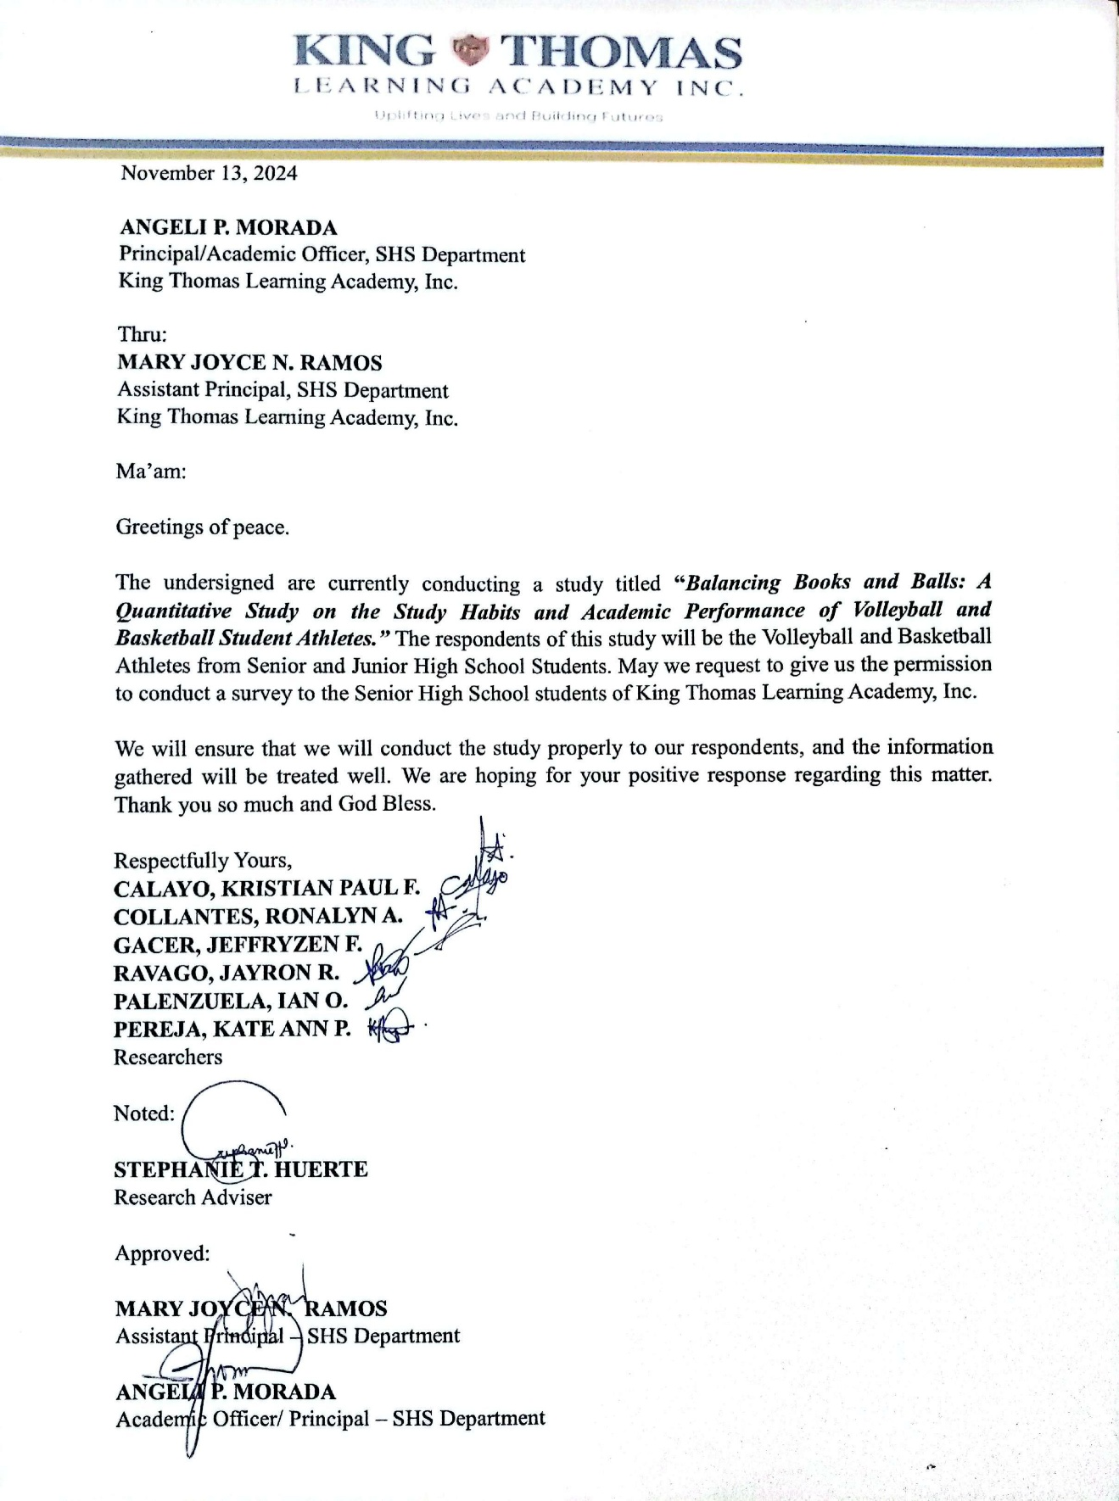

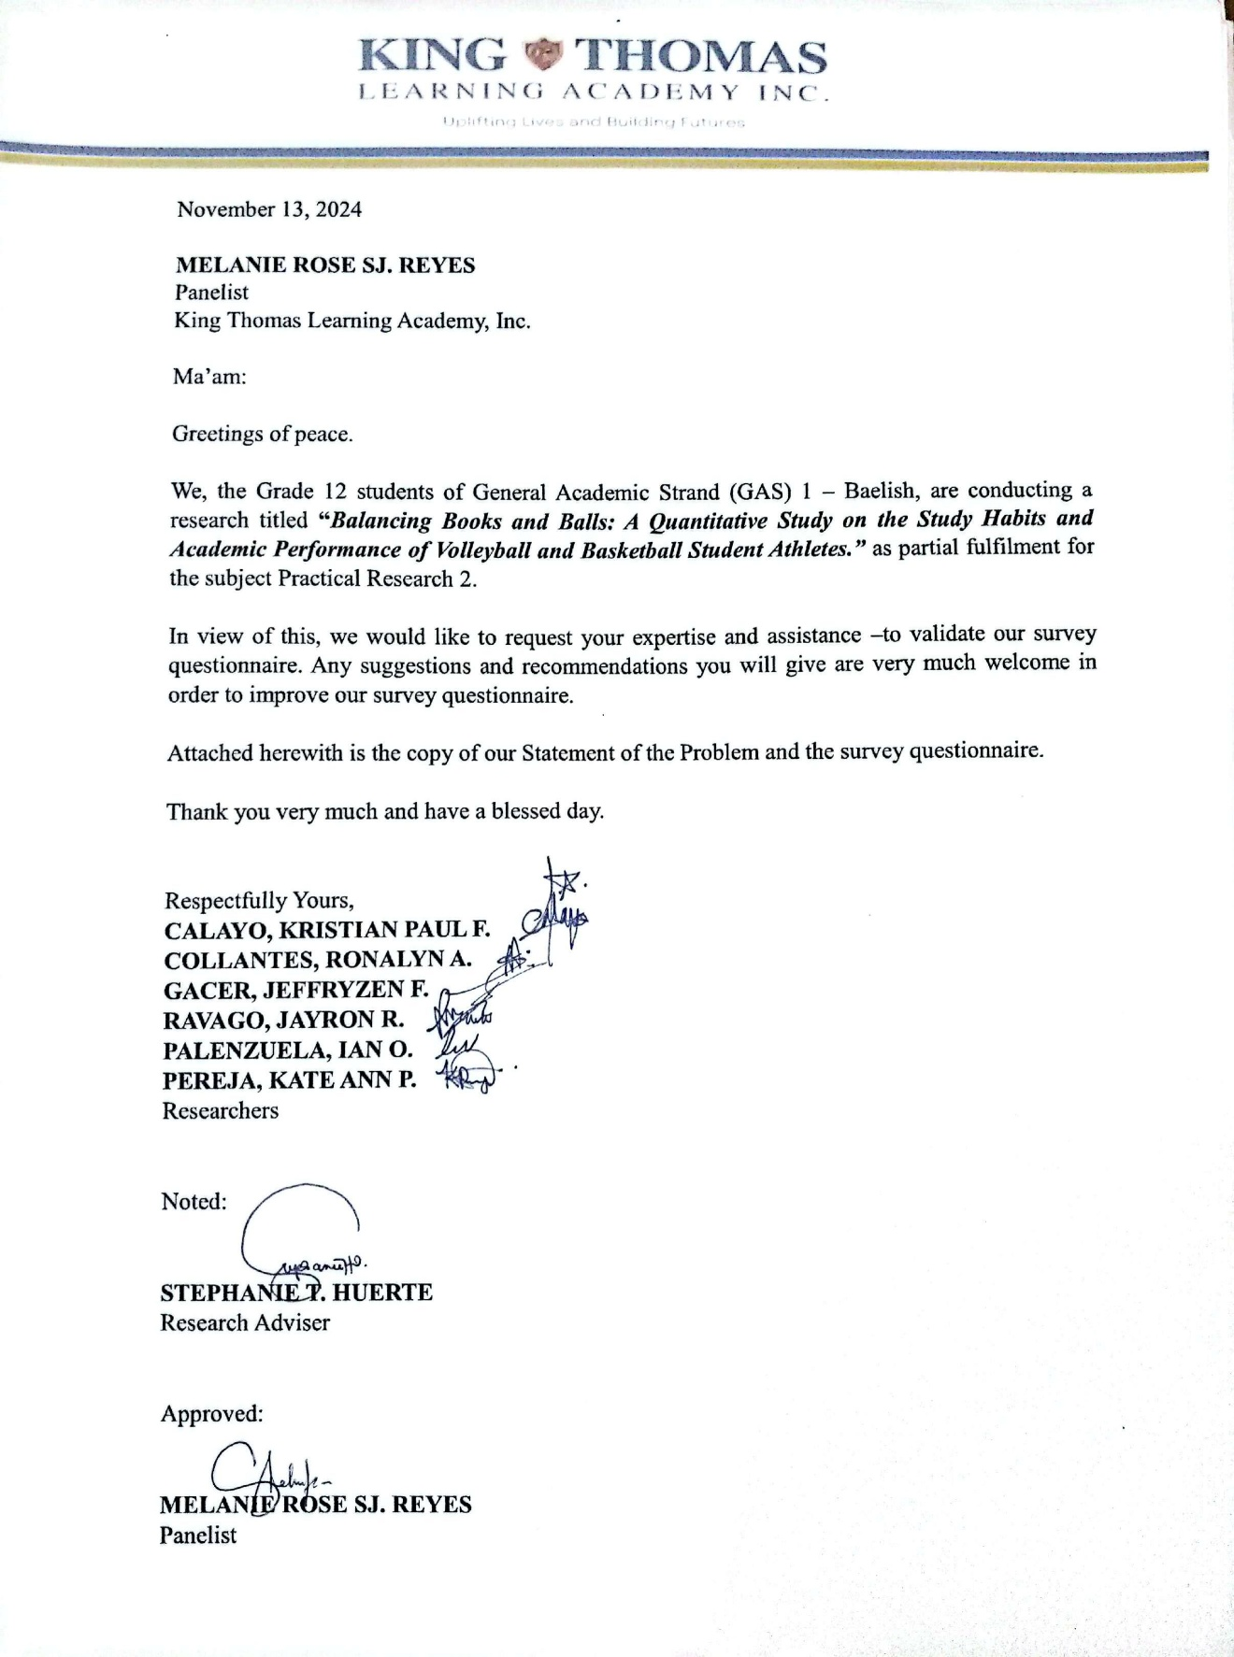

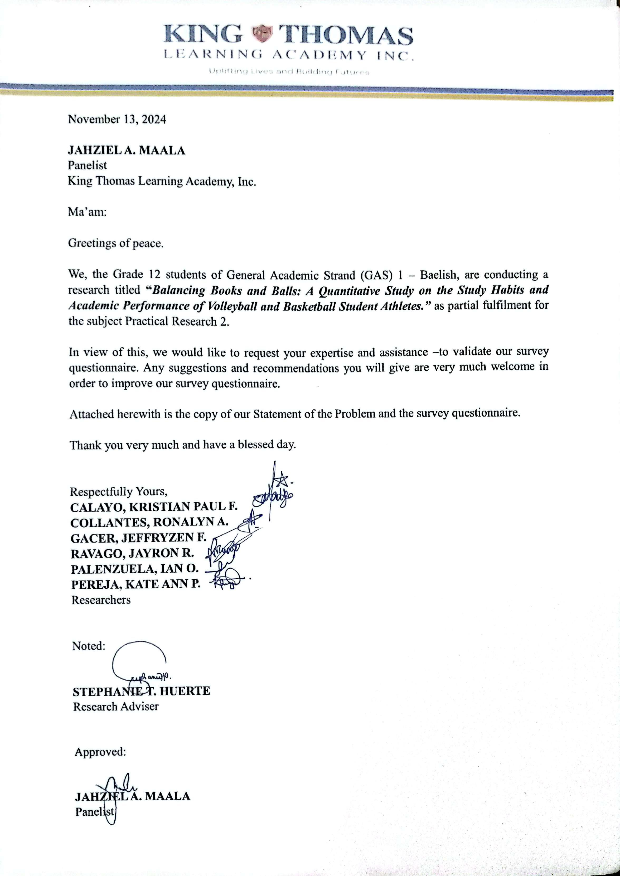

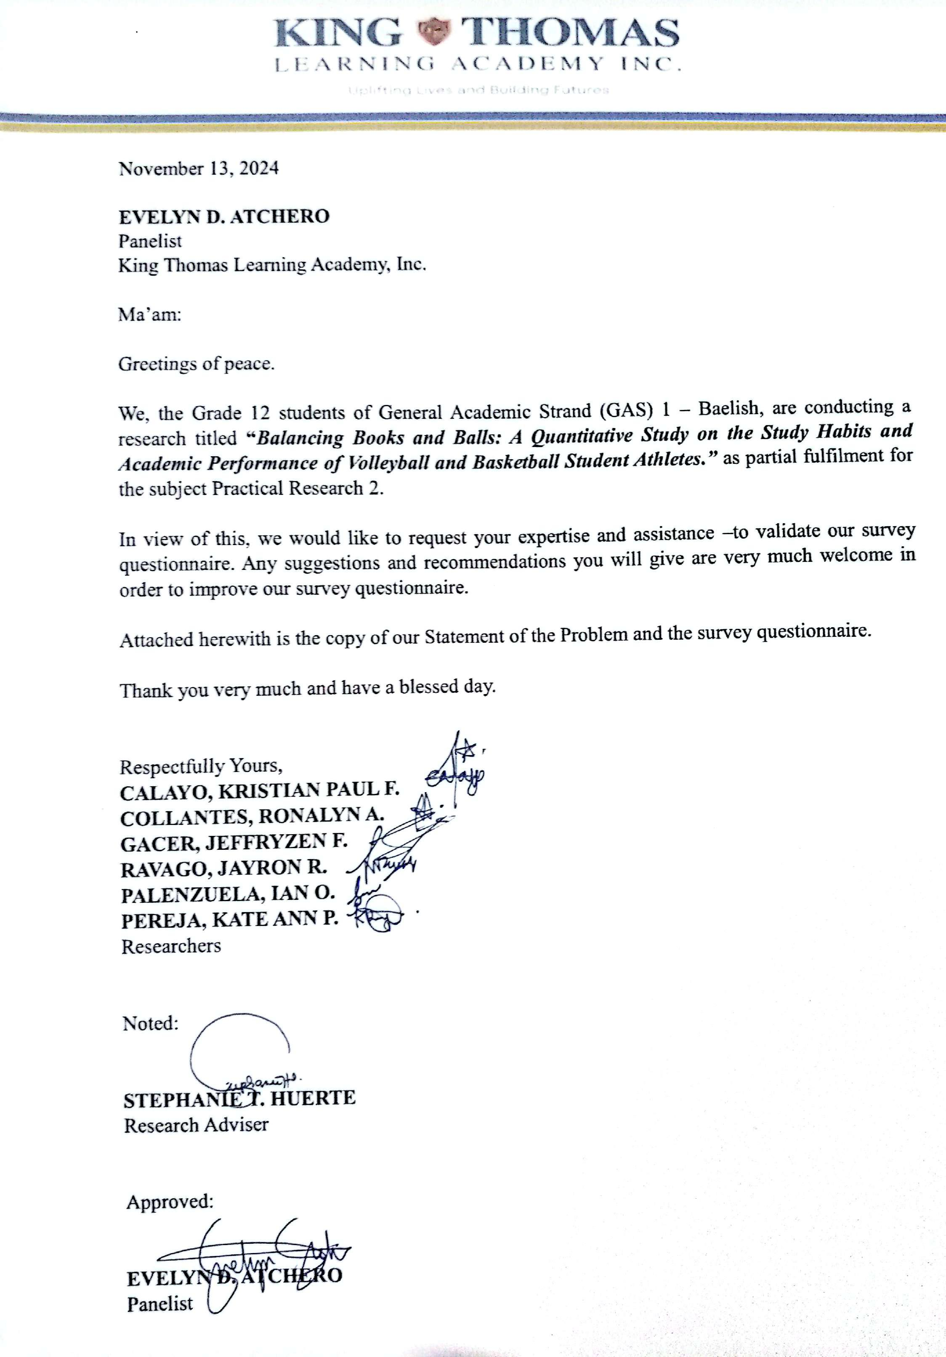

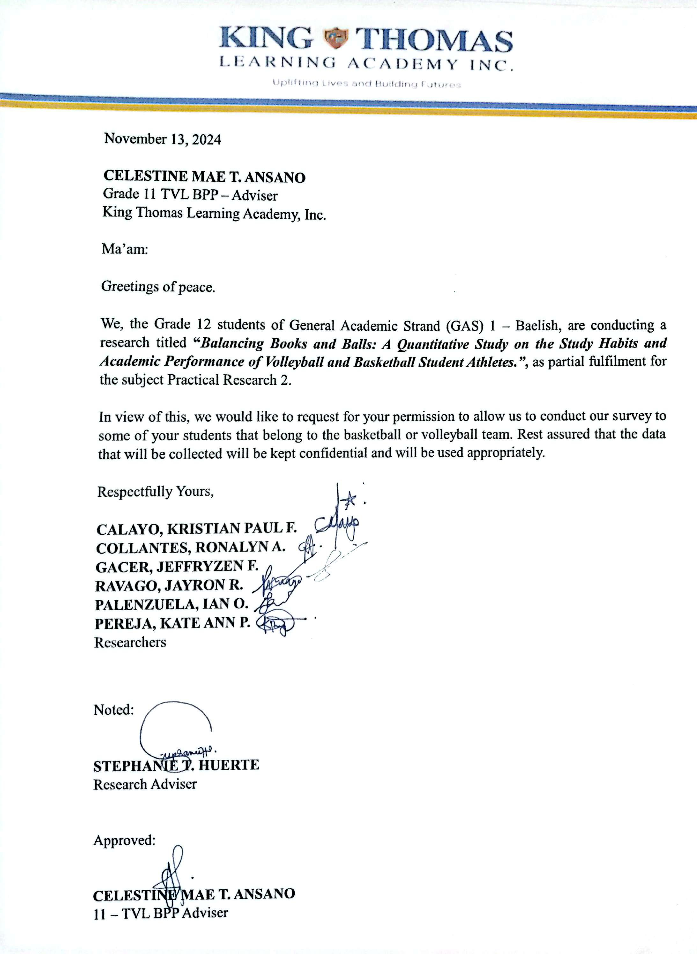

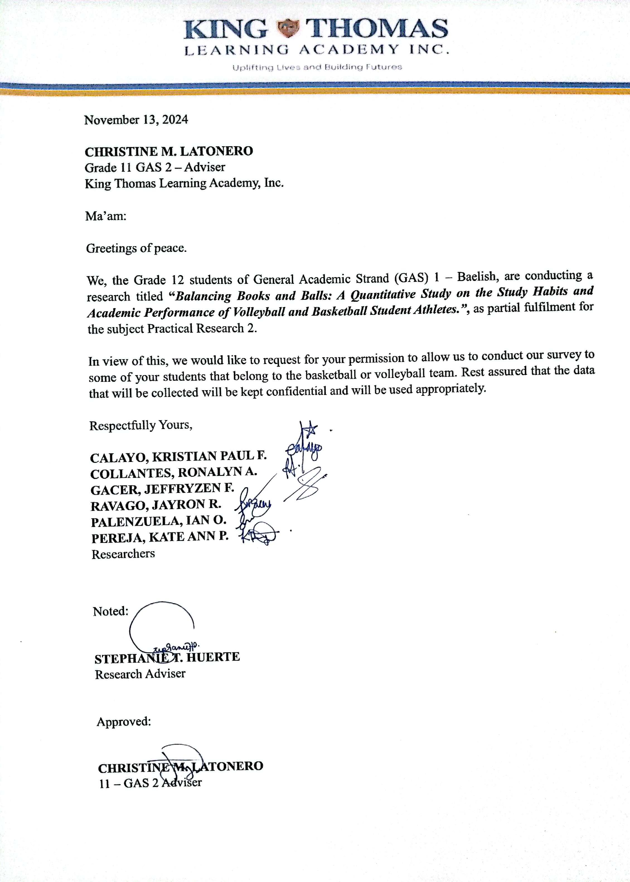

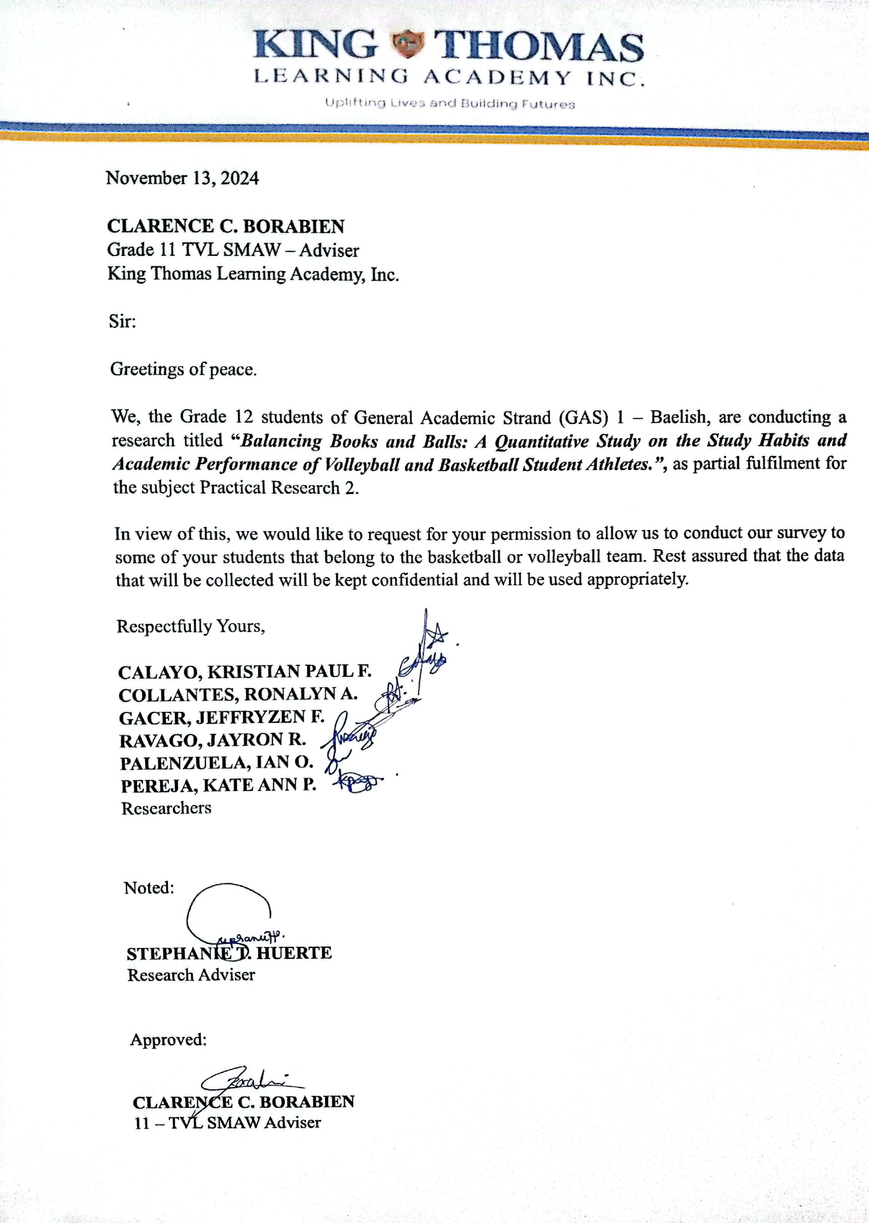

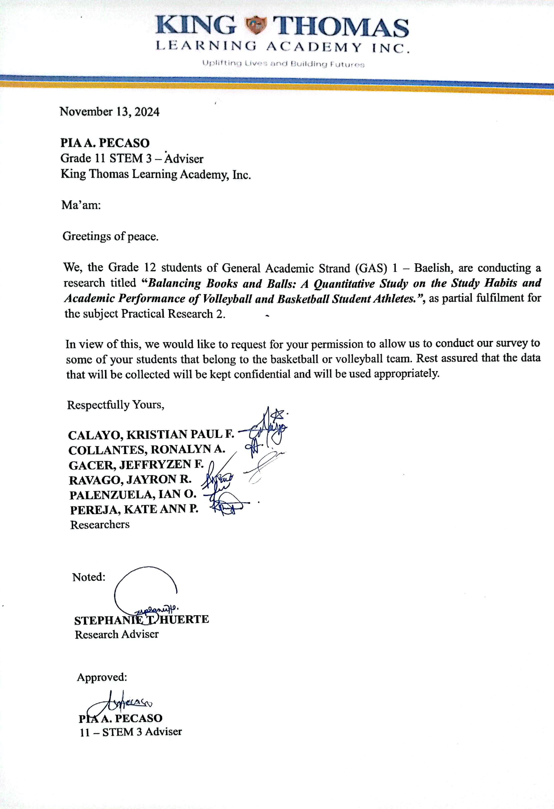

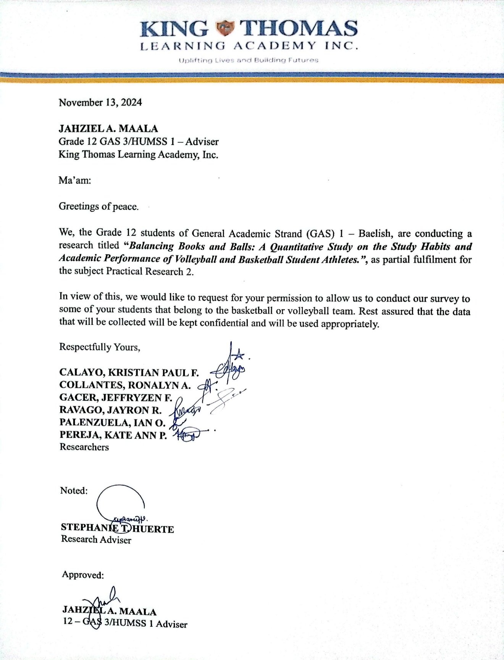

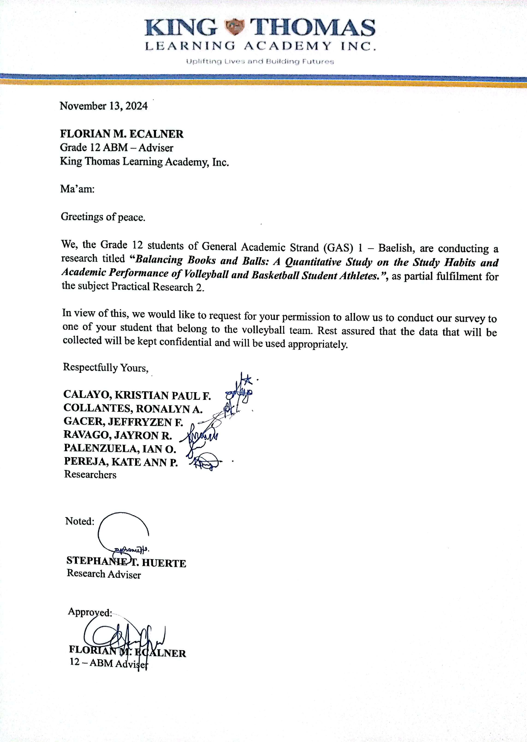

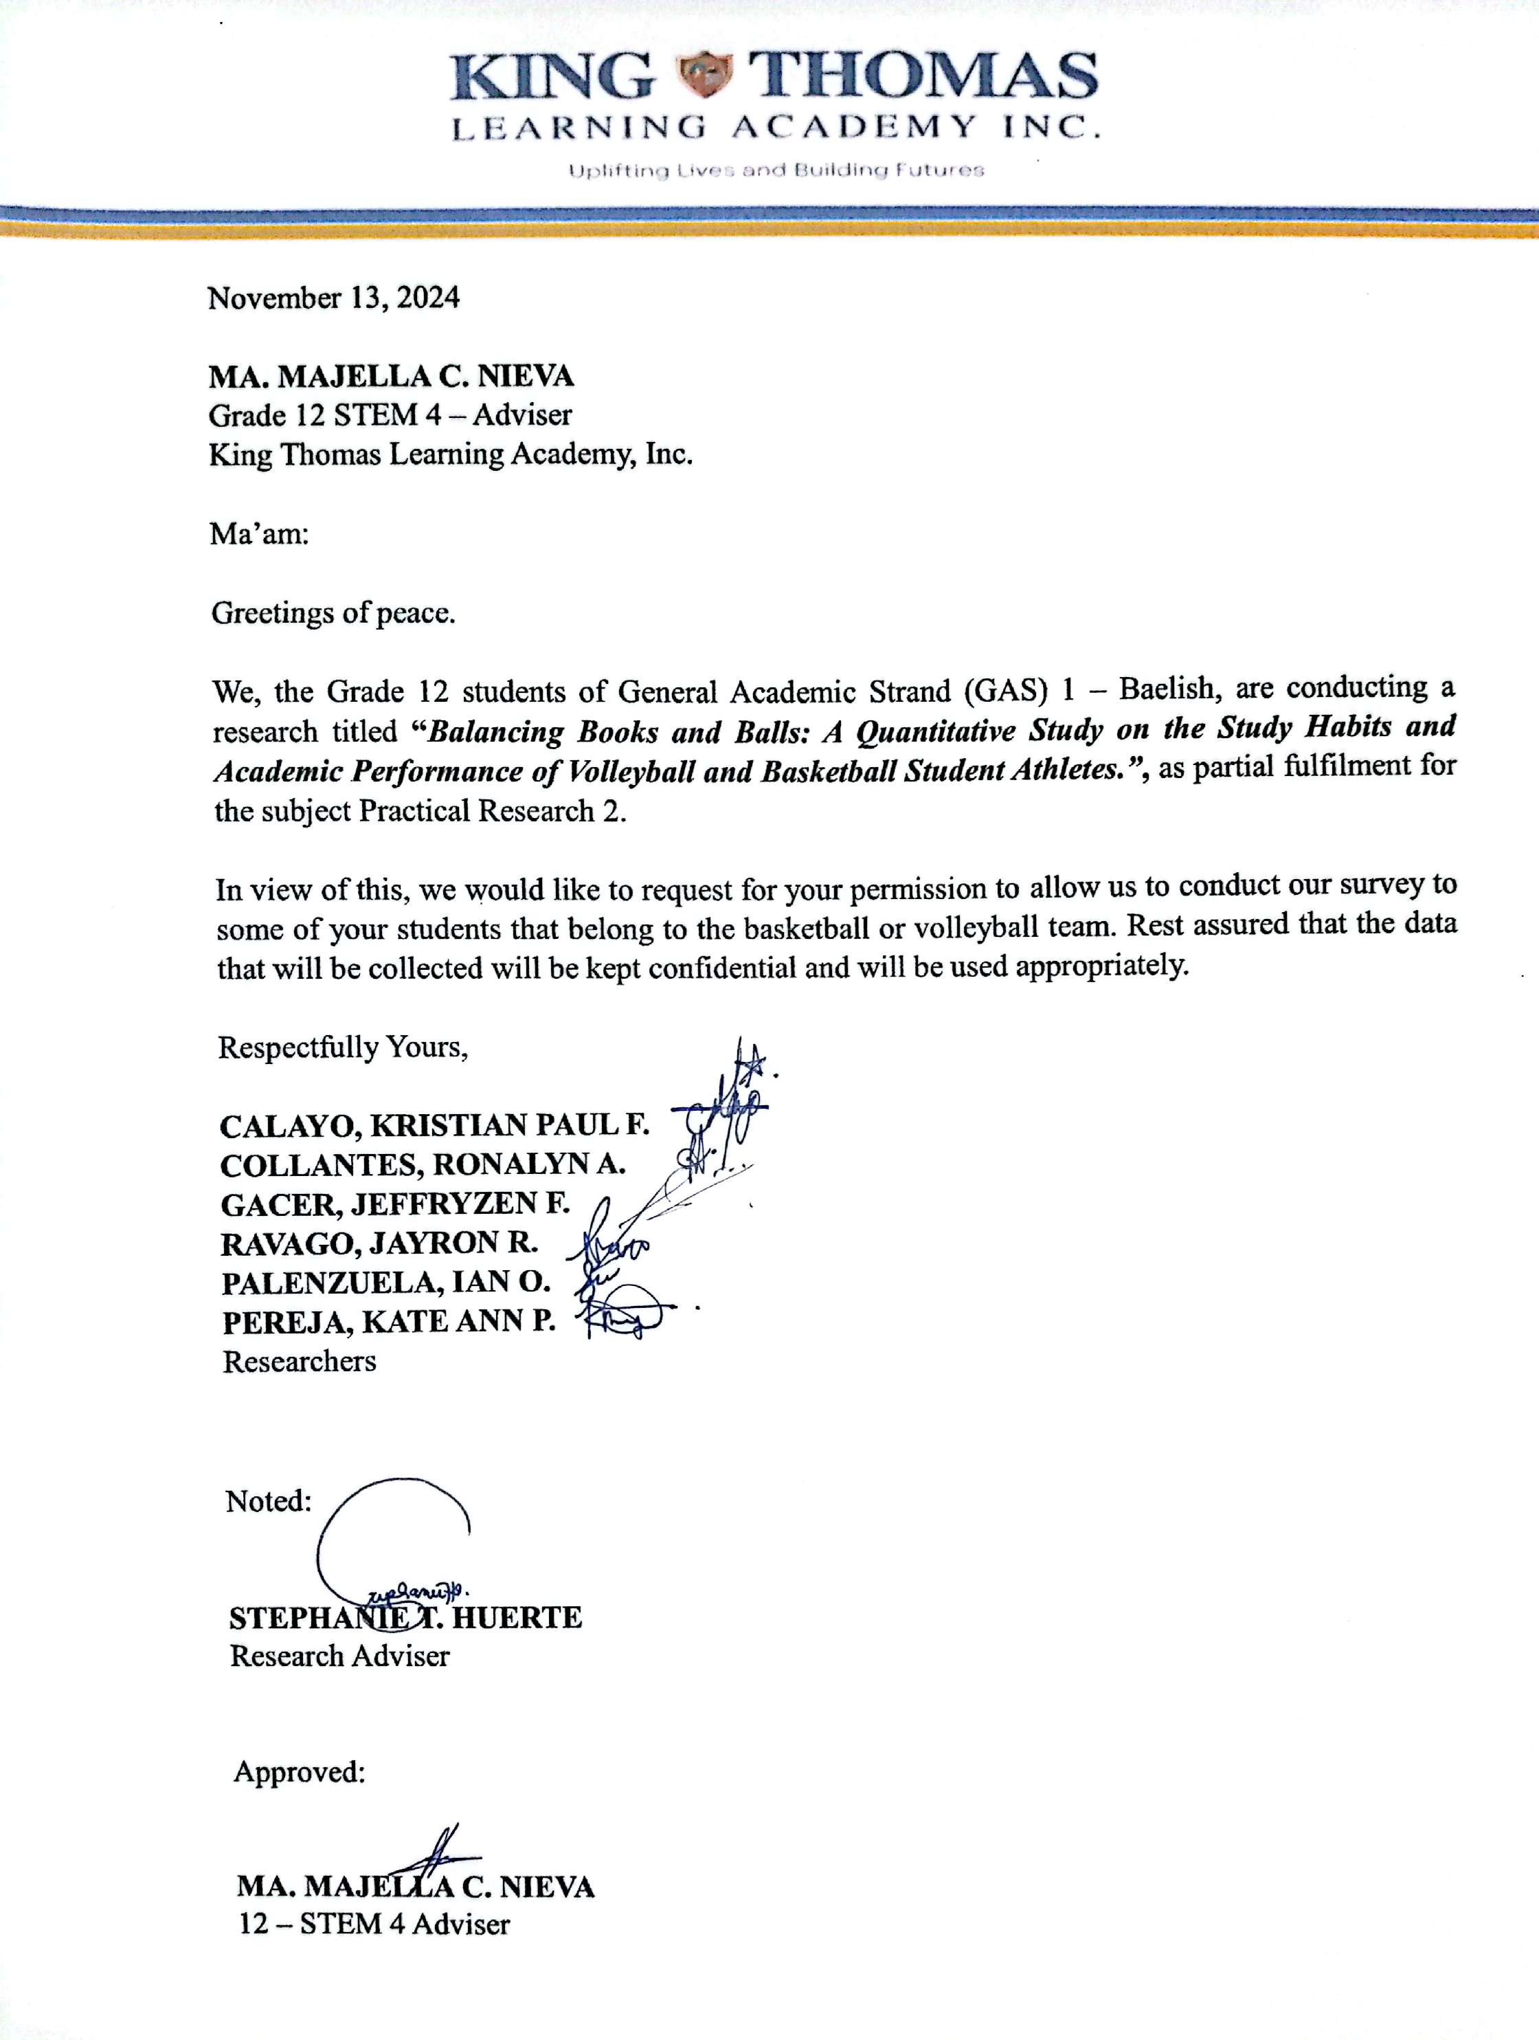

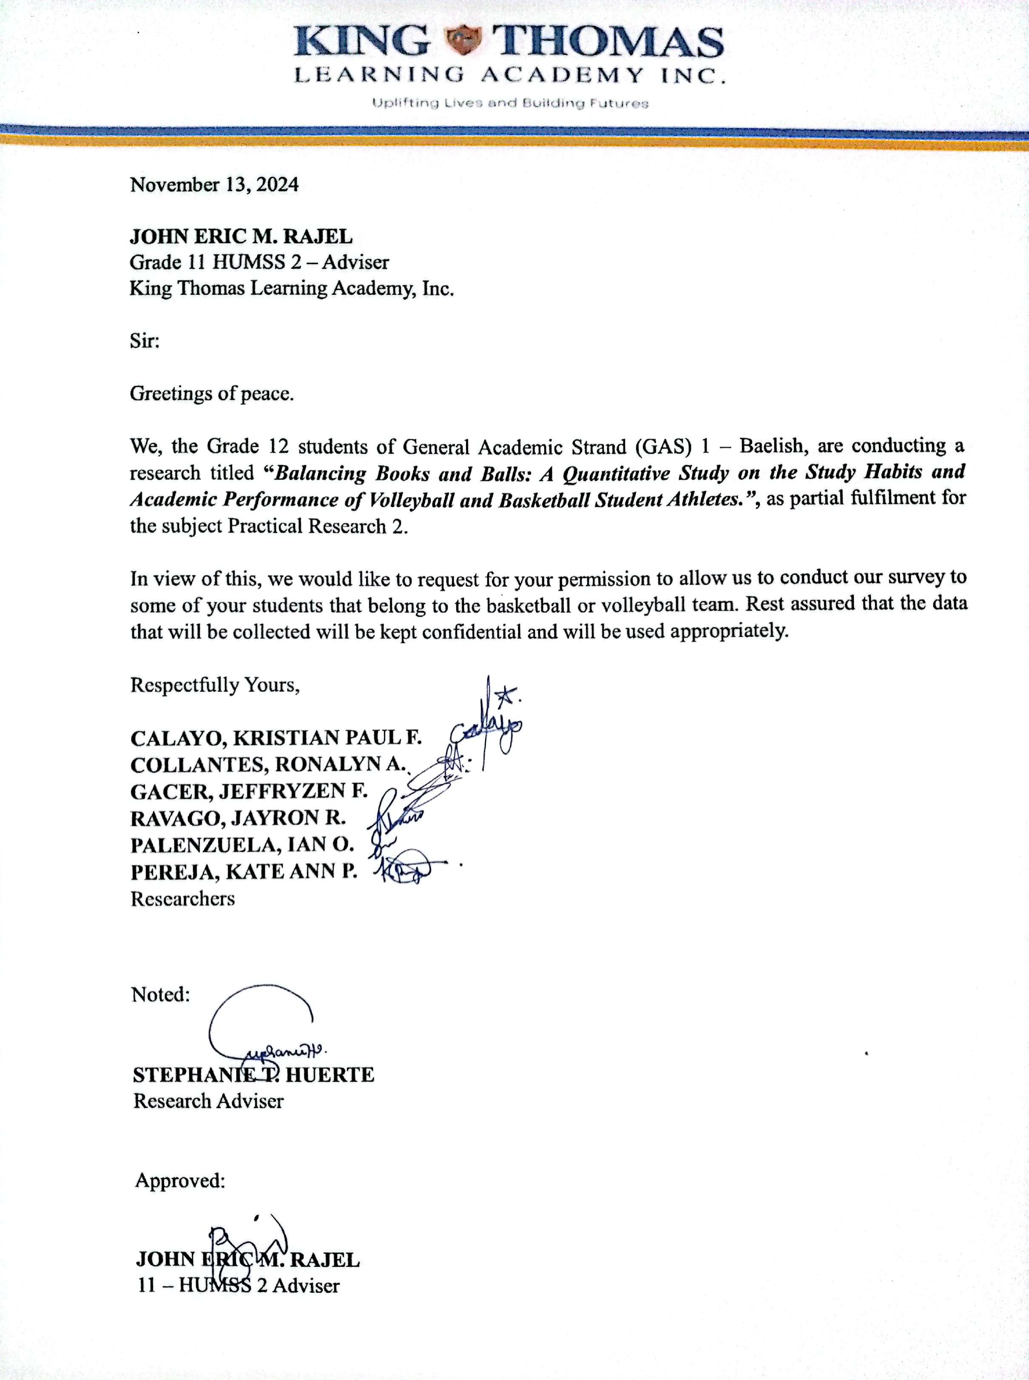

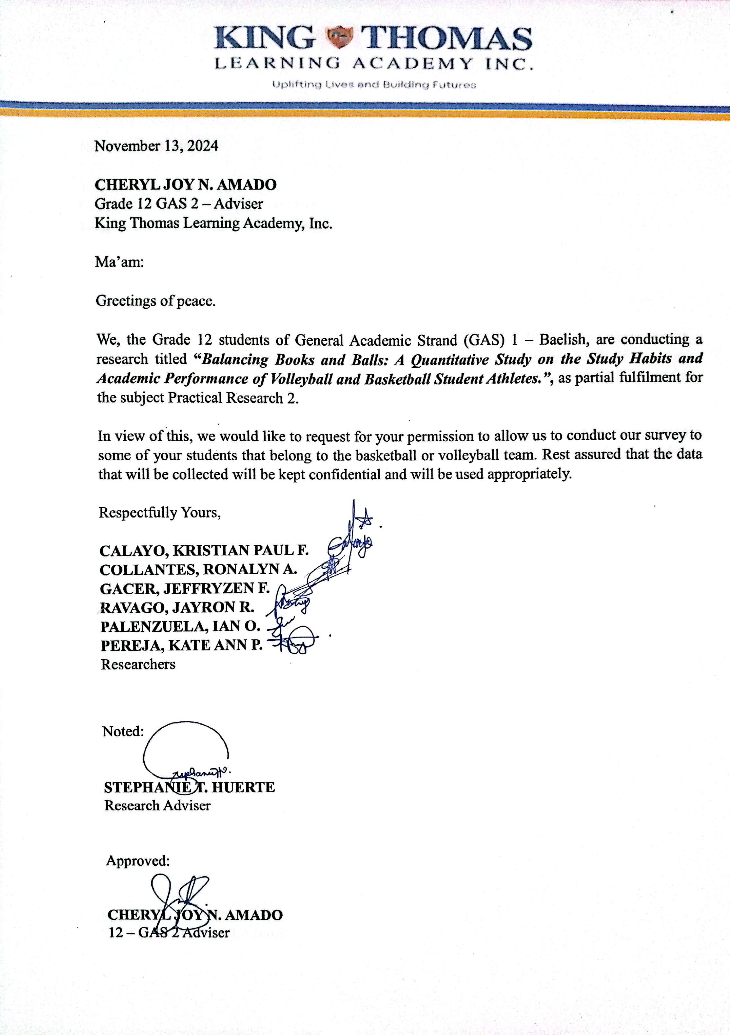

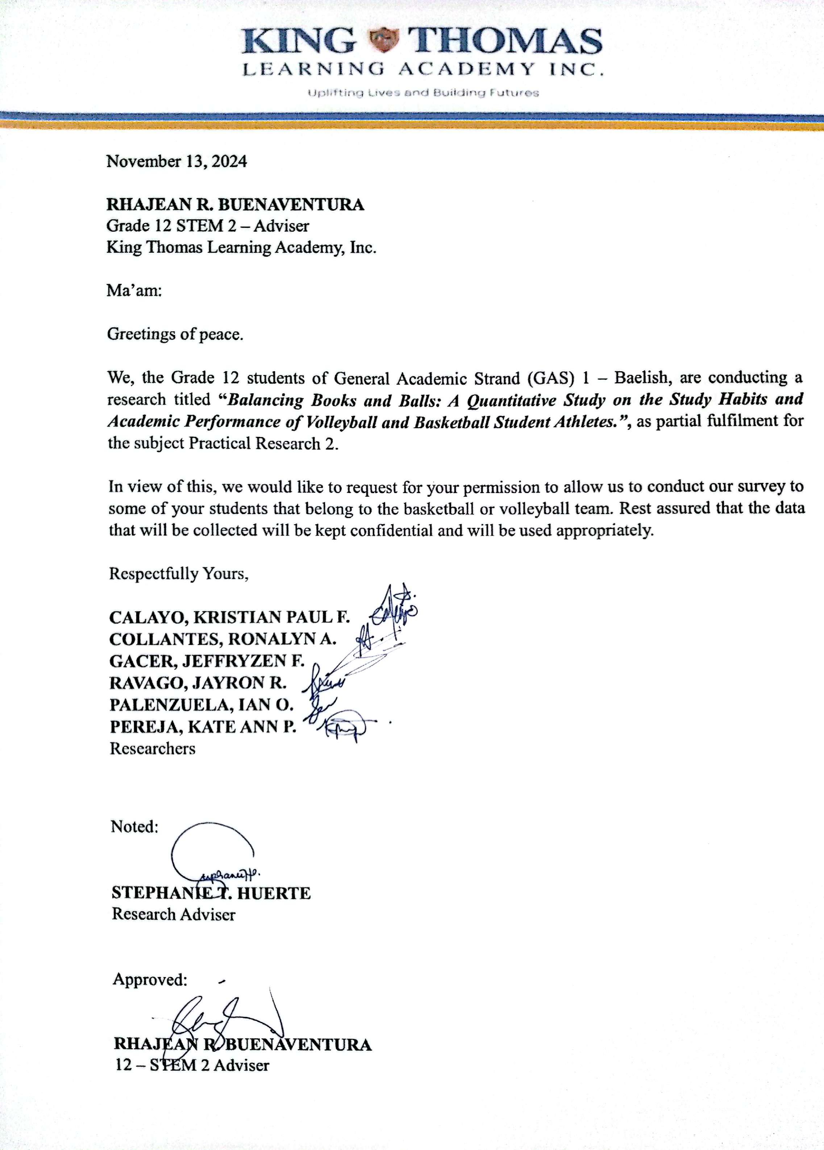

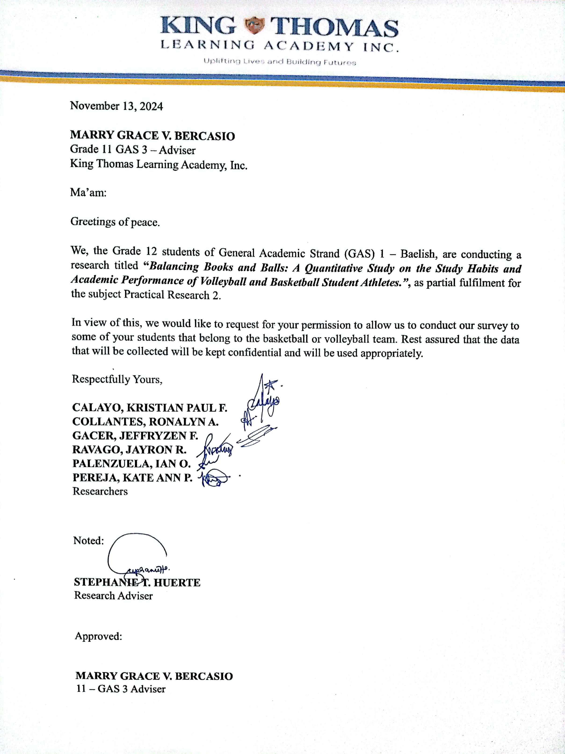

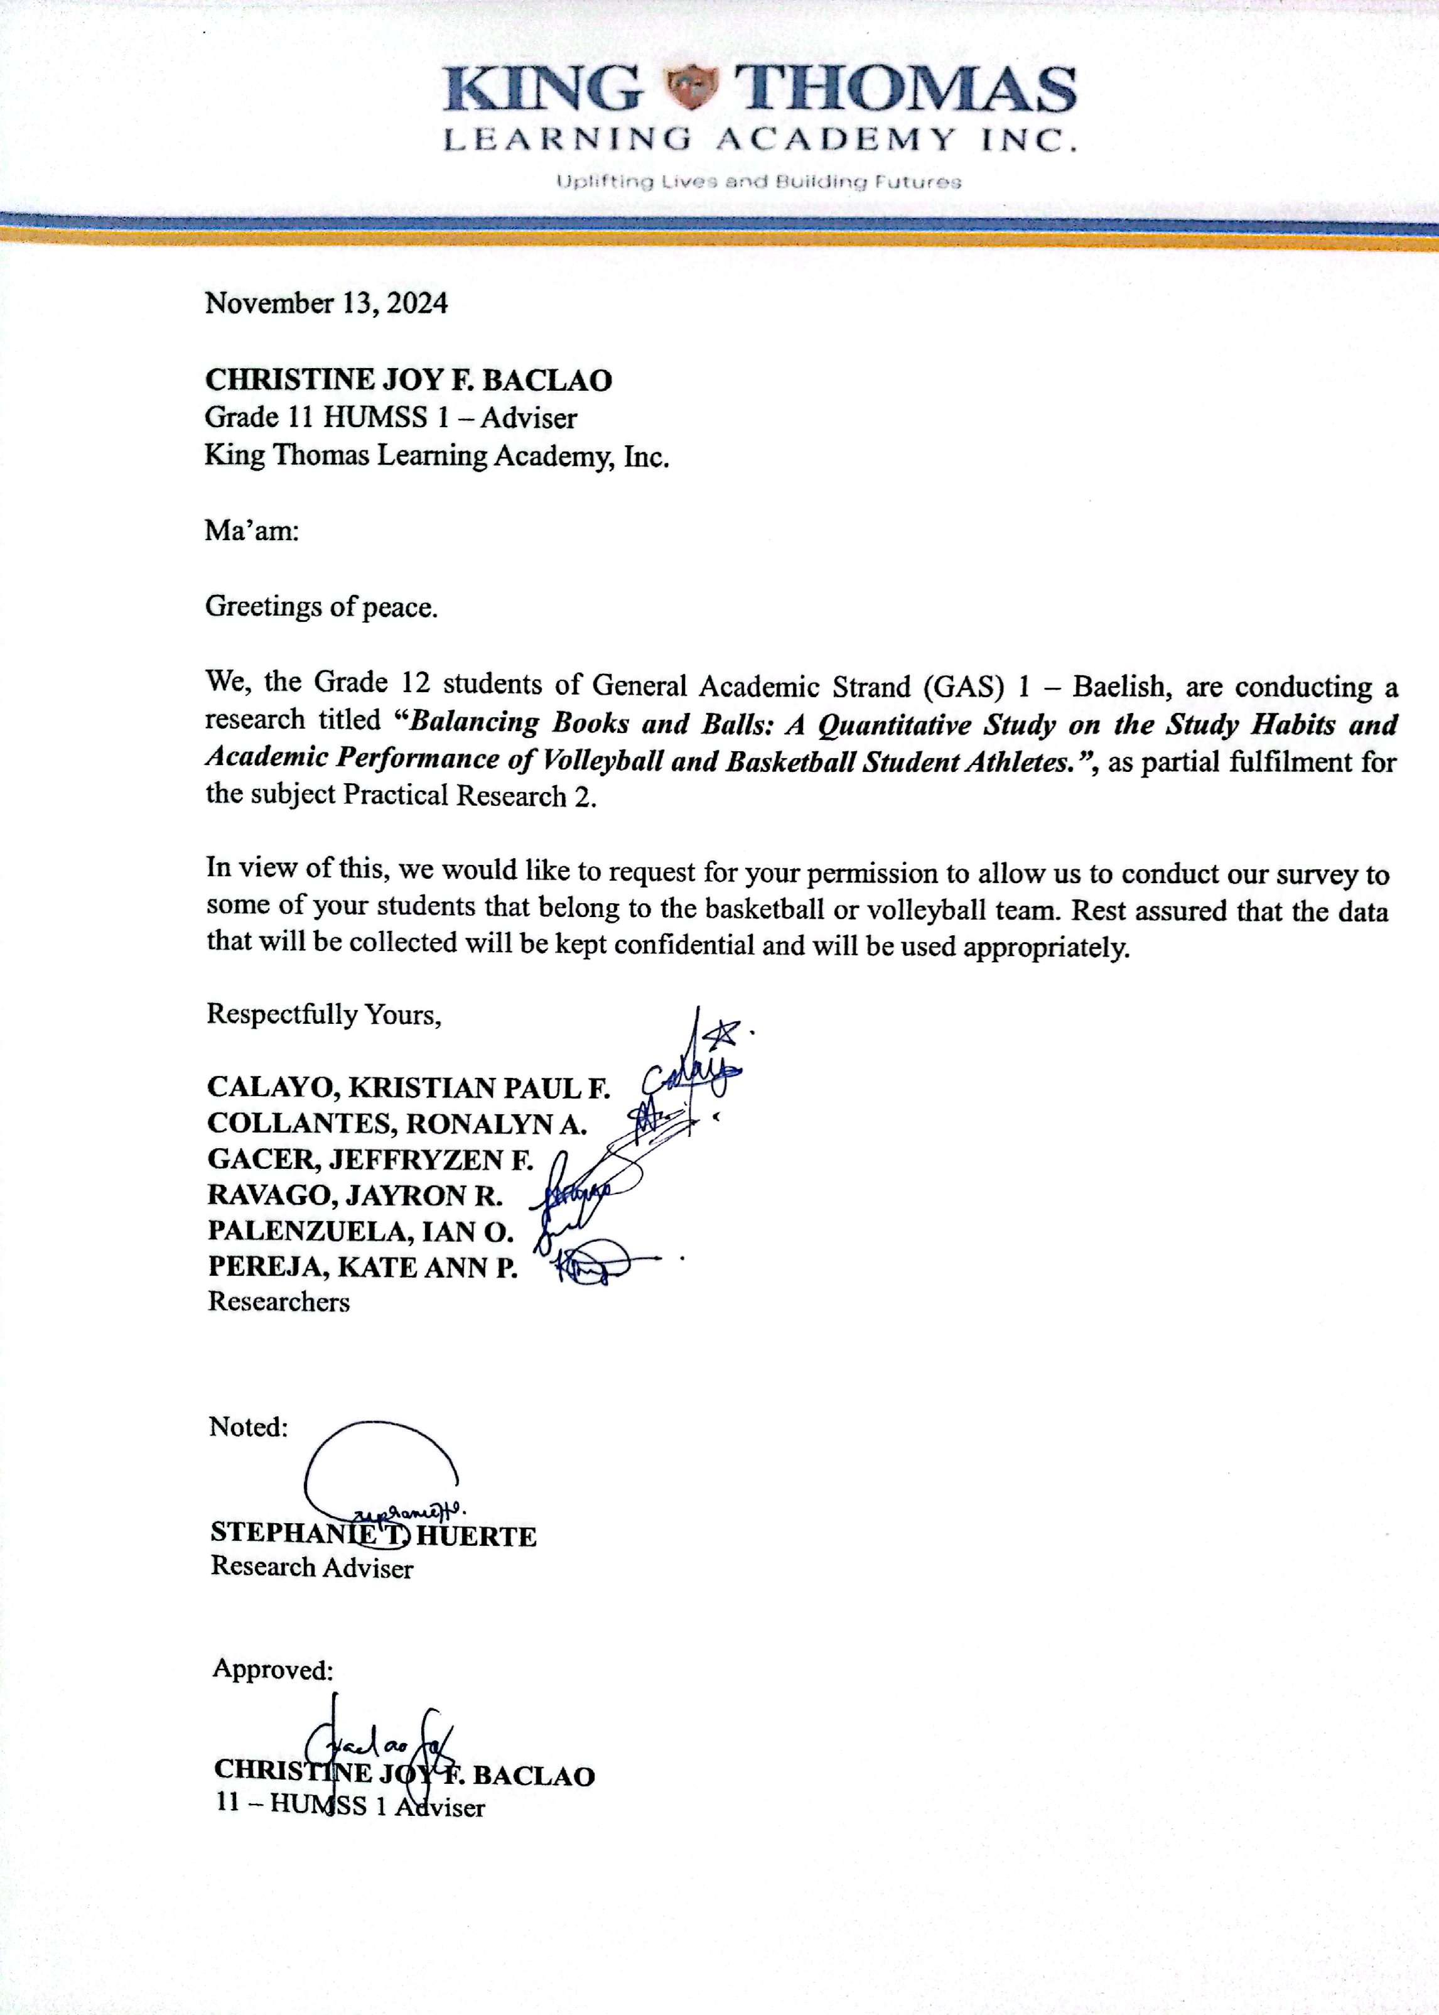

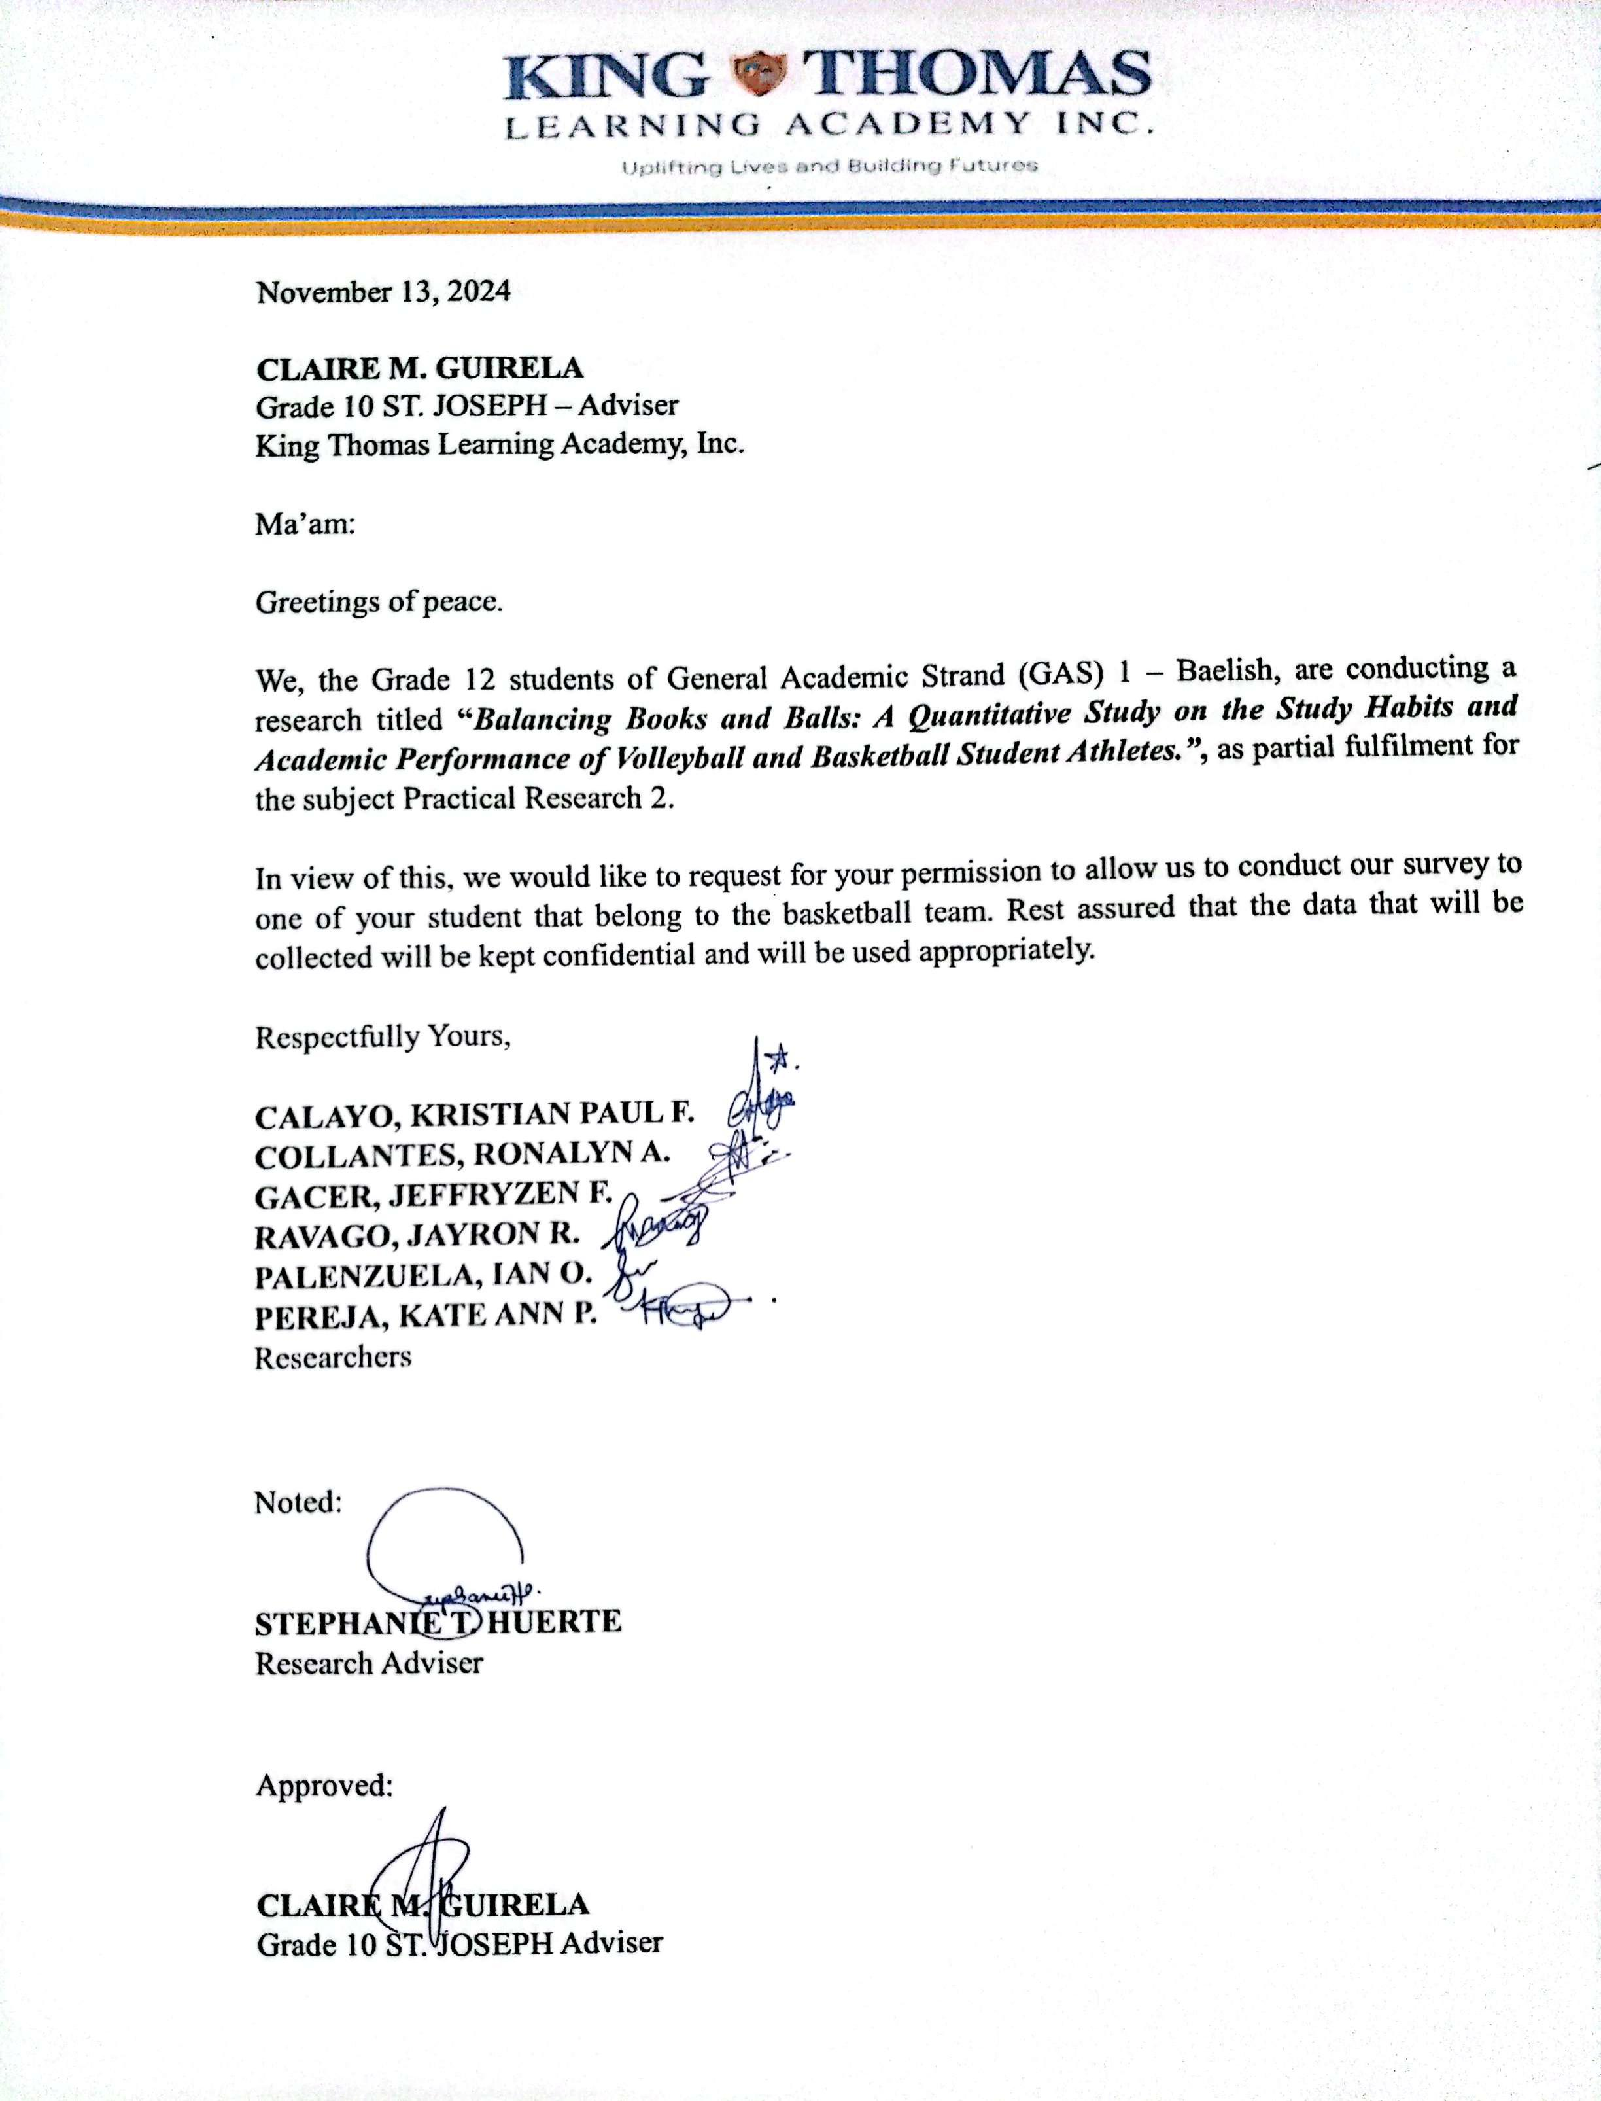

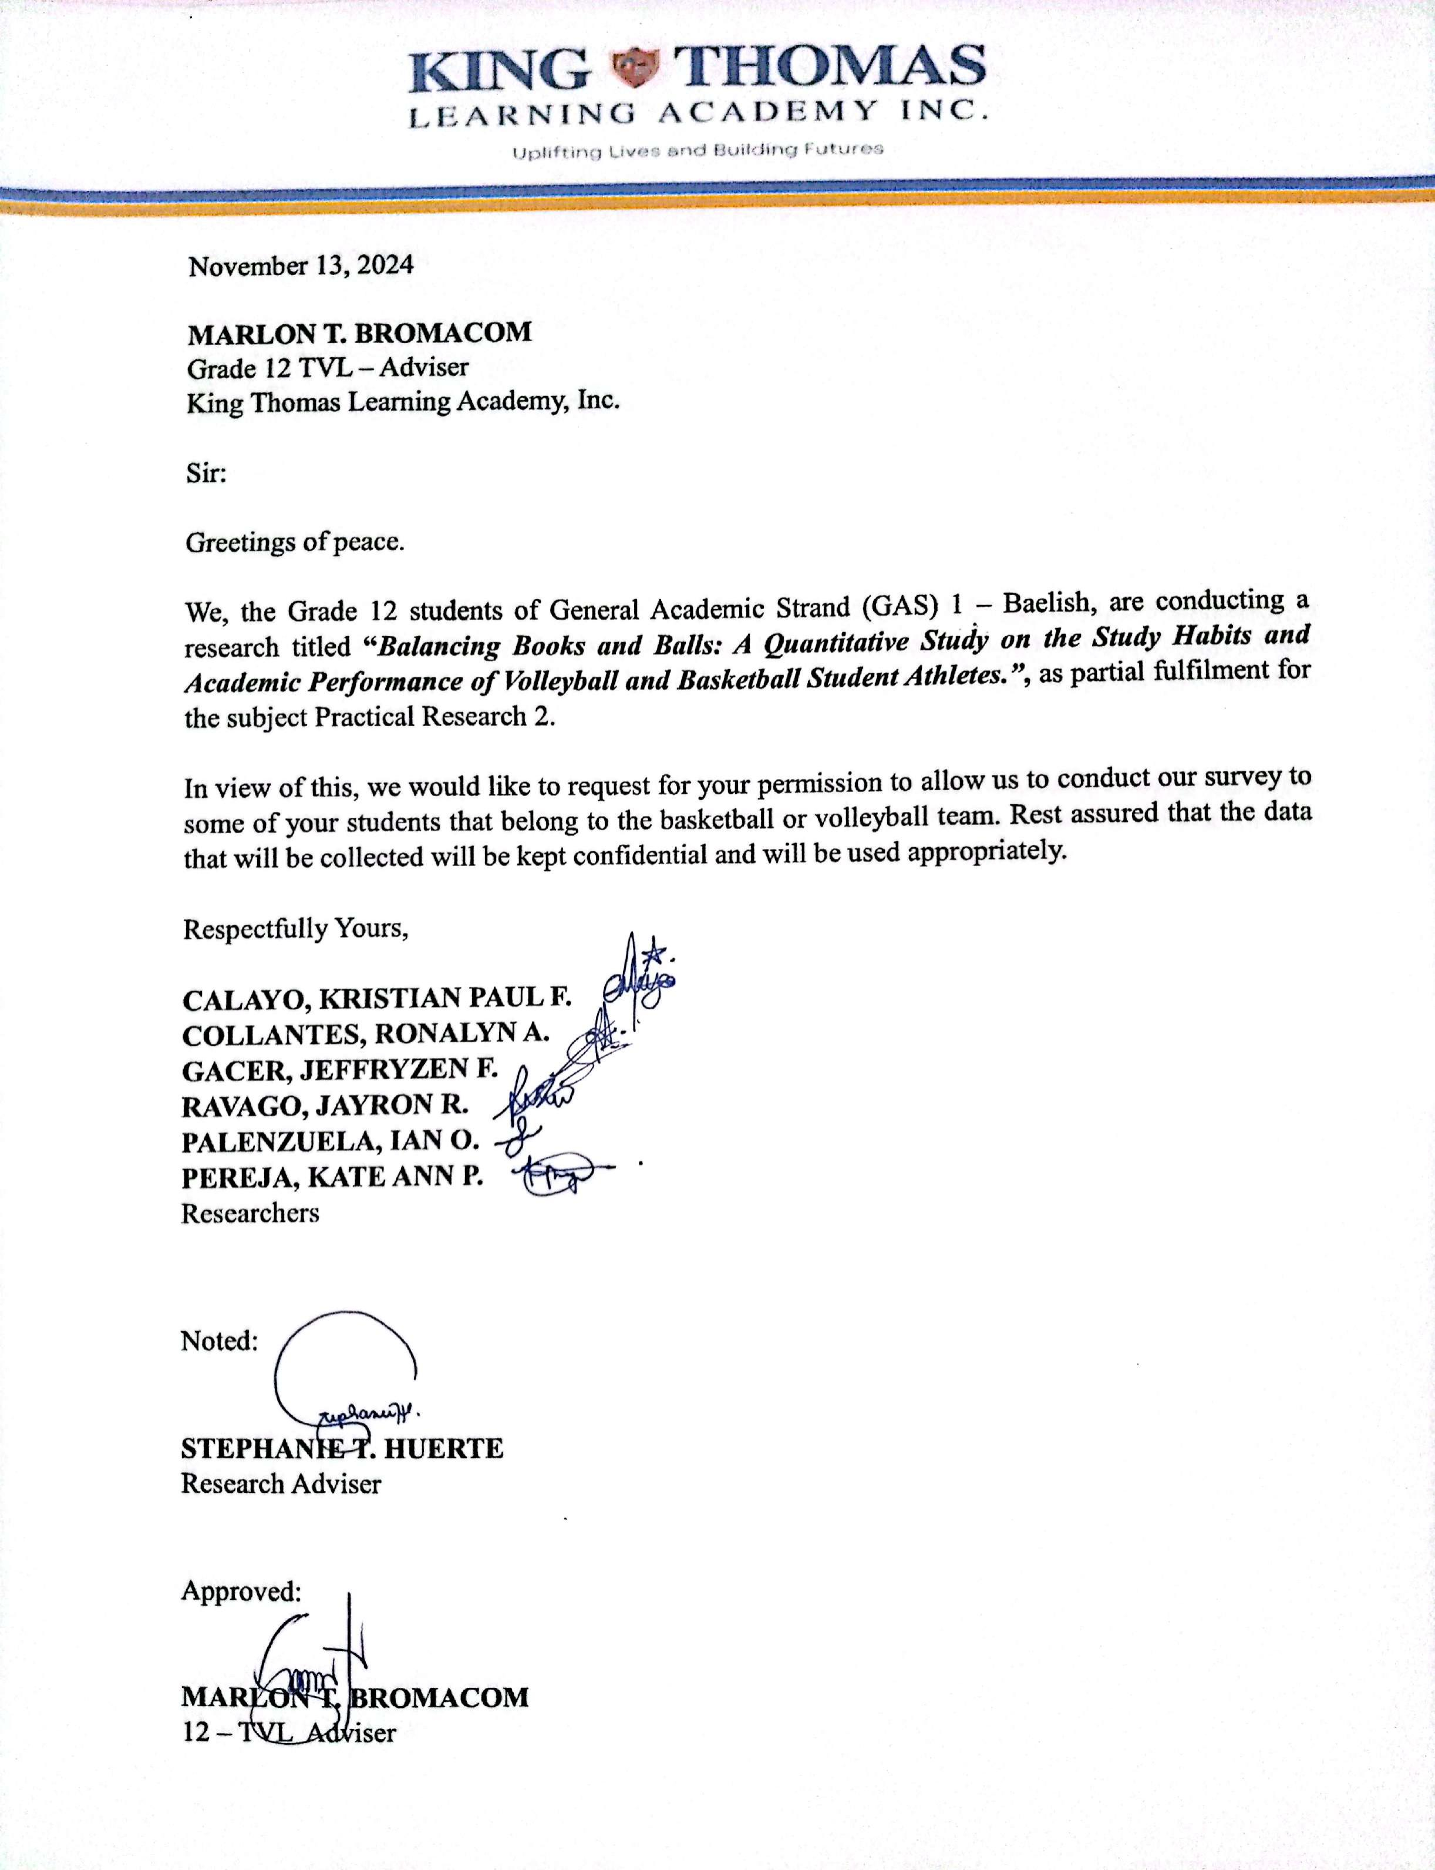

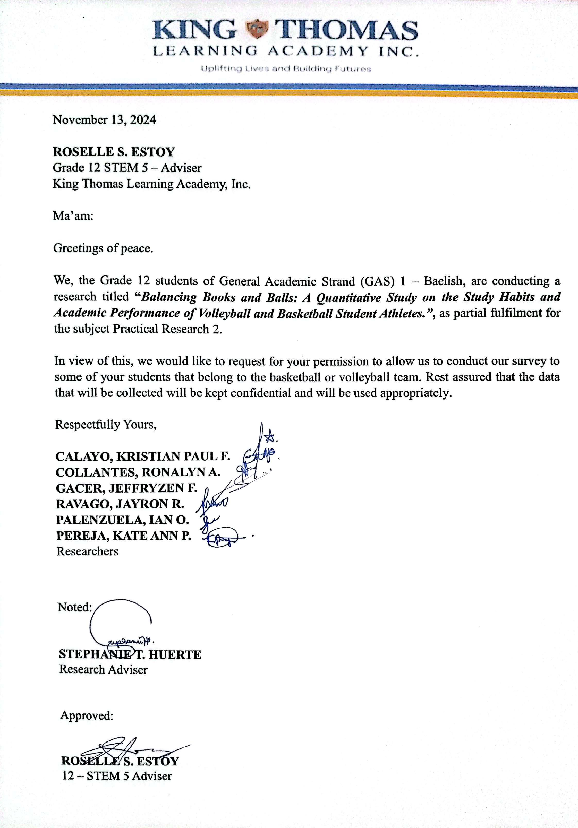

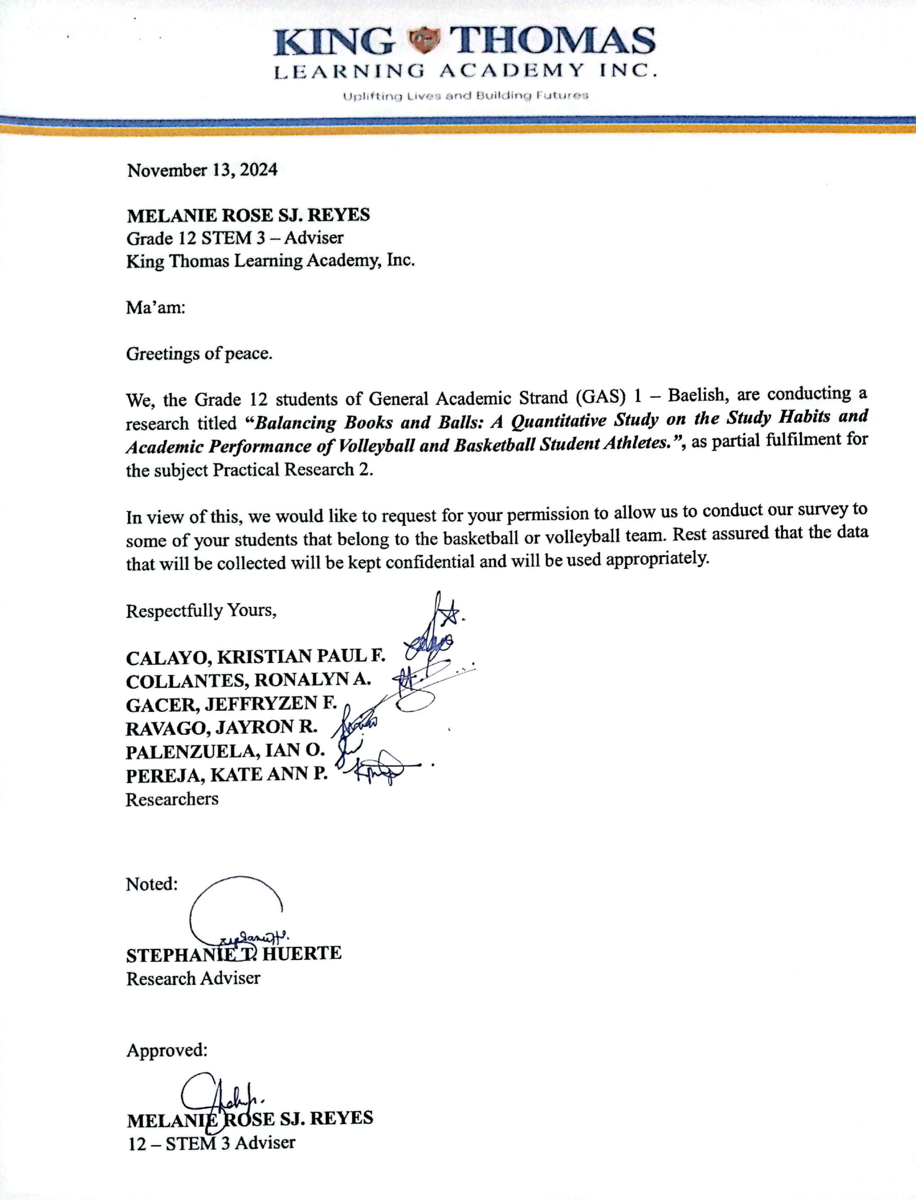

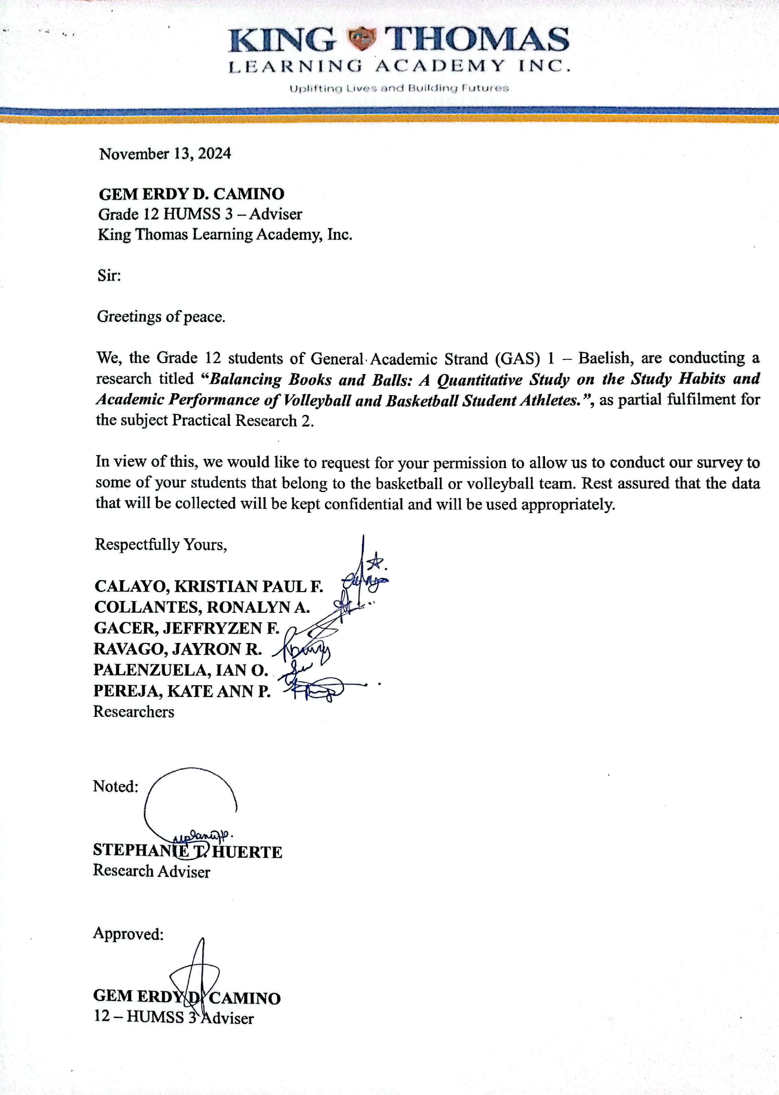

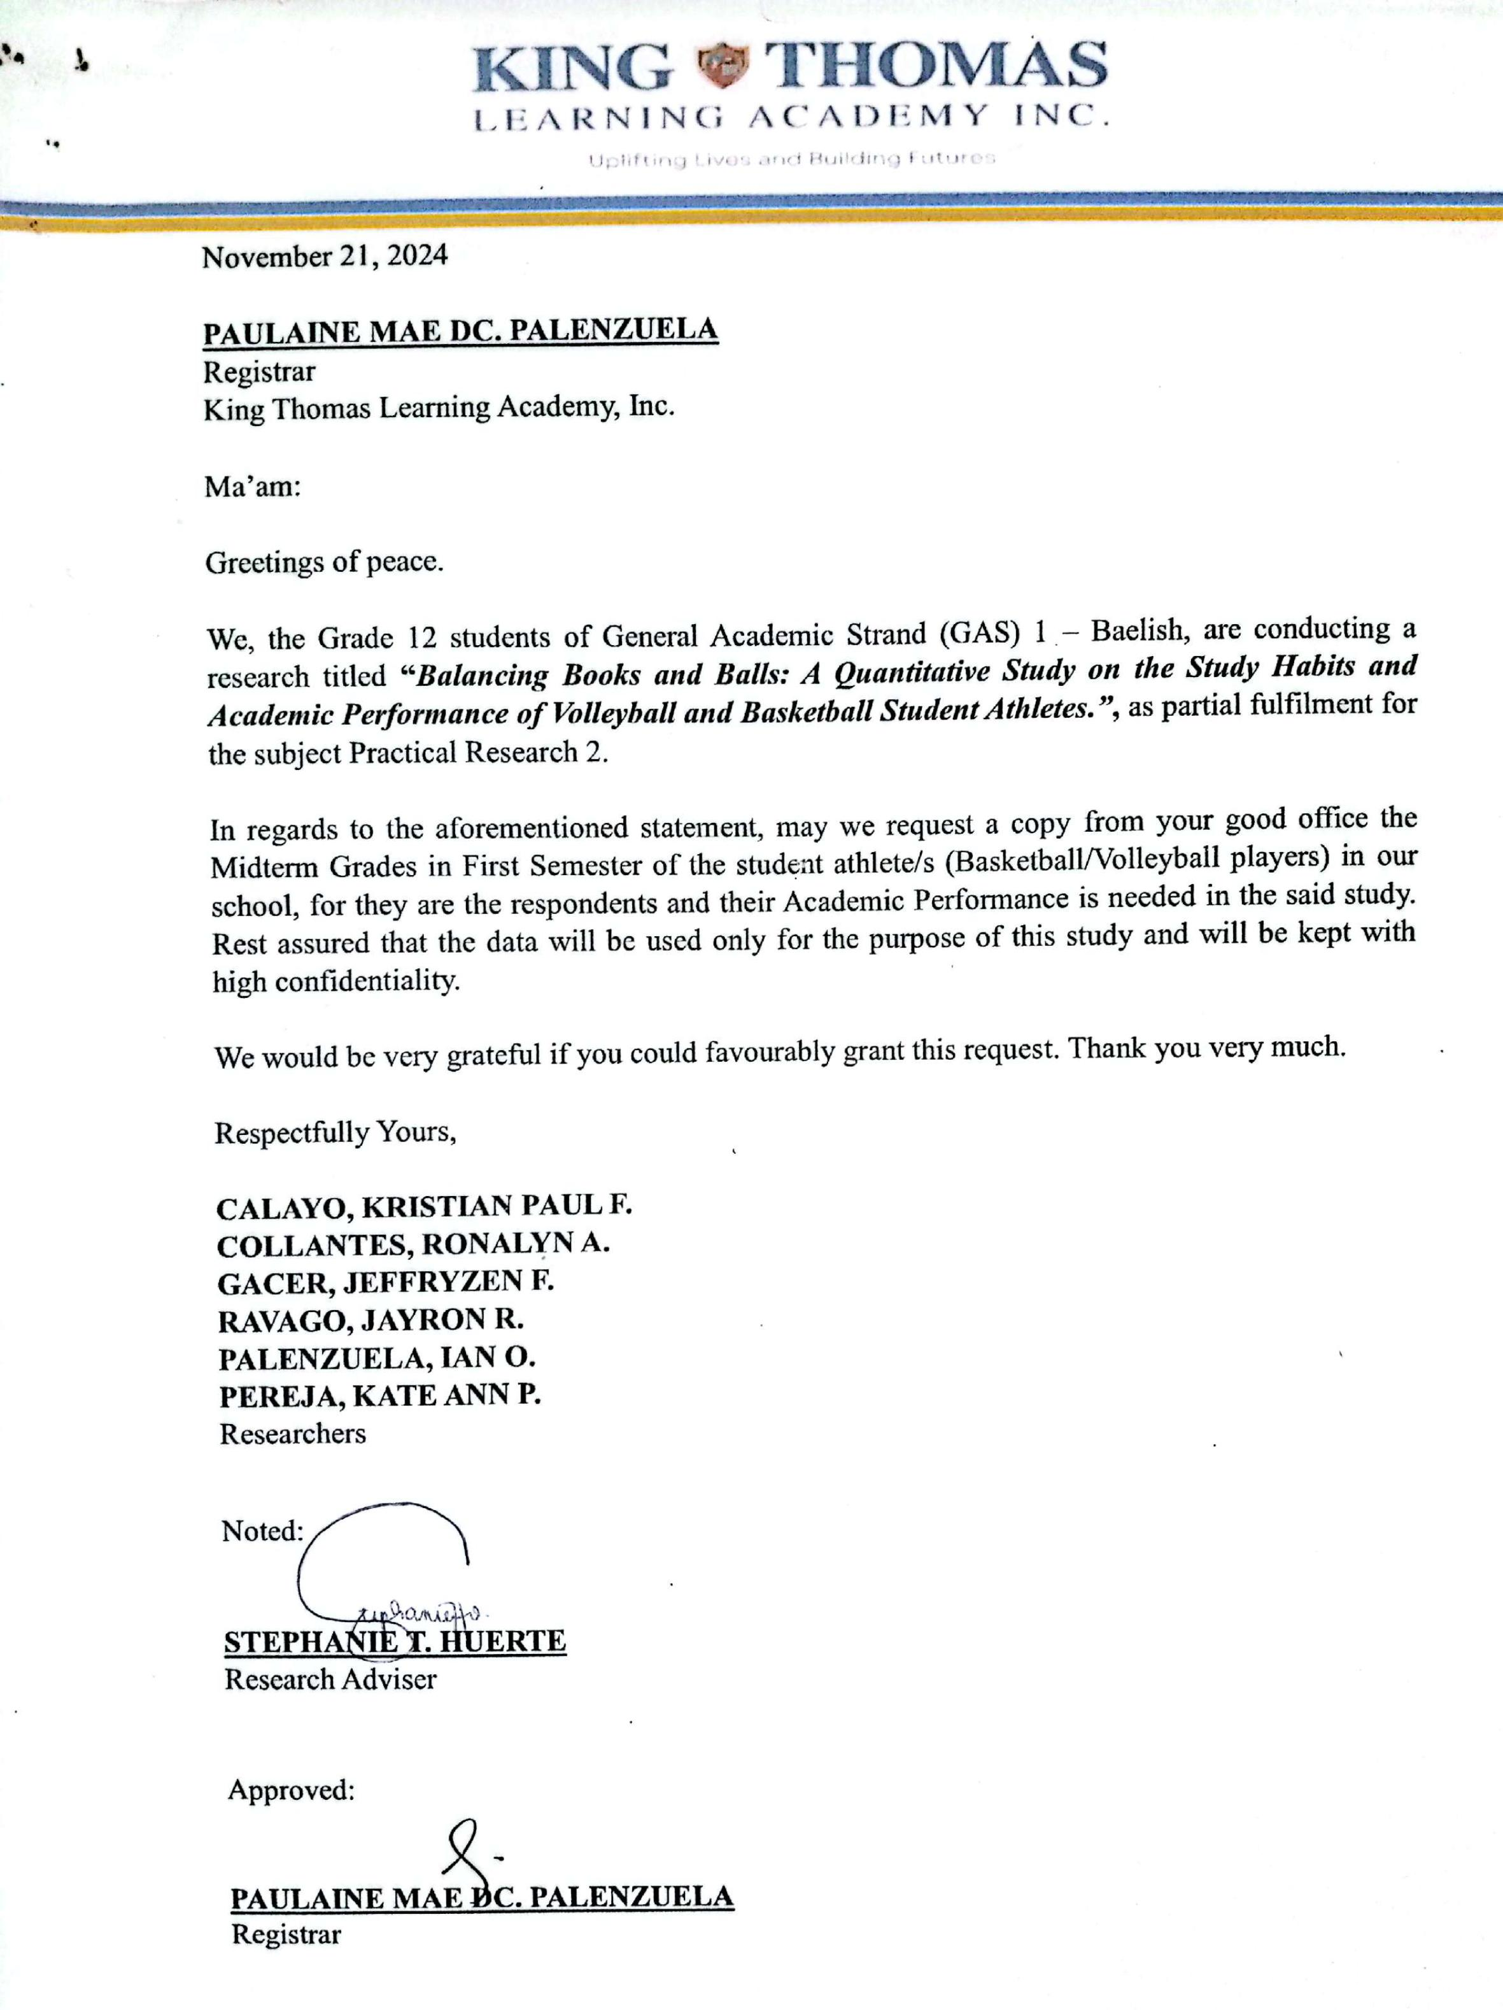

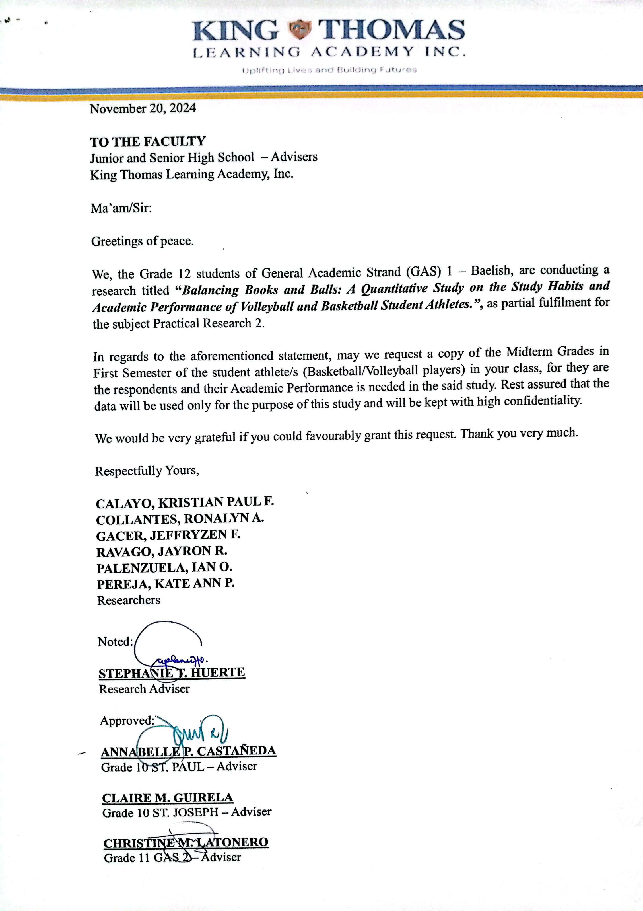

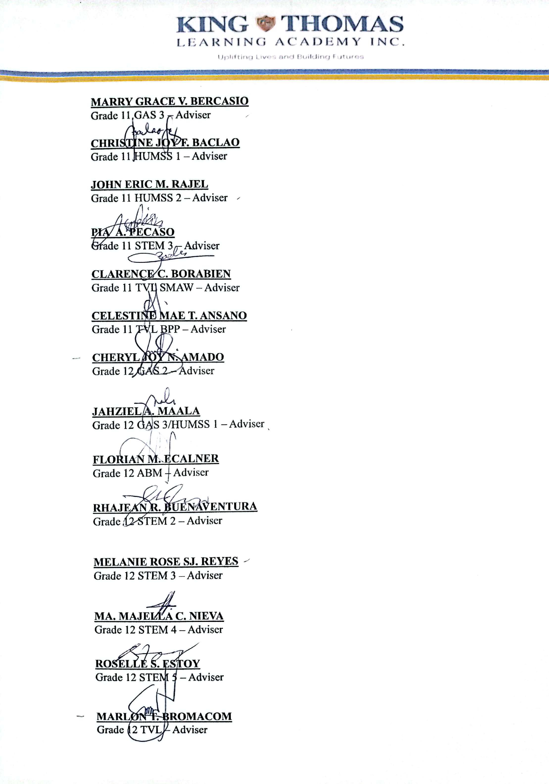

**APPENDIX C**

**SAMPLE QUESTIONNAIRE**

**Balancing Books and Balls: A Quantitative Study on the Study Habits and Academic Performance of Volleyball and Basketball Student Athletes**

Dear Respondent,

The researchers value your privacy and we will not share any of your personal information or individual responses with anyone. We will use the data you provide for research purposes only.

Respectfully yours,

Researchers

**Name:** (Optional) **Date:** _____________

**Age:** **Sex:** __________

**Direction:** Indicate your level of evaluation in each question below regarding the study habits of basketball athletes in terms of time management, effective communication, and self-discipline. Place a check (/) on the column that corresponds to your answer.

Legend:

4 – Strongly Agree 2 – Disagree

3 – Agree 1 – Strongly Disagree

1. What are the study habits of volleyball and basketball student athletes in terms of:

|  |  |  |  |  |
| --- | --- | --- | --- | --- |
| **Time Management** | **Strongly agree (4)** | **Agree**  **(3)** | **Disagree**  **(2)** | **Strongly Disagree**  **(1)** |
| 1. I manage my time between training and academic schedules. |  |  |  |  |
| 1. I complete my academic assignments on time before training. |  |  |  |  |
| 1. I set specific hours each day for studying. |  |  |  |  |
| 1. I take regular breaks to avoid burnout. |  |  |  |  |
| 1. I make a planner or calendar schedule to keep track of deadlines. |  |  |  |  |
| 1. I do not create a study schedule that balances all subjects, and I do not bother to give more time to those that require more attention. |  |  |  |  |
| 1. I often do procrastination. |  |  |  |  |
| 1. I do not bother setting personal deadlines for homework and activities. |  |  |  |  |
| 1. I fail to complete my performance task on time. |  |  |  |  |
| 1. I do not ask my coach and peers about training schedules. |  |  |  |  |

|  |  |  |  |  |
| --- | --- | --- | --- | --- |
| **Active Learning** | **Strongly**  **Agree**  **(4)** | **Agree**  **(3)** | **Disagree**  **(2)** | **Strongly Disagree**  **(1)** |
| 1. I take notes during class lectures. |  |  |  |  |
| 1. I make questions that could appear on future examinations and quizzes. |  |  |  |  |
| 1. I ensure that I have all my supplies when I study, such as pens, papers, etc. |  |  |  |  |
| 1. I make keywords for memorizing. |  |  |  |  |
| 1. I rewrite what I need to memorize. |  |  |  |  |
| 1. I skip summarizing my notes in my own words, leading to poor understanding. |  |  |  |  |
| 1. I do not bother highlighting keywords when writing notes. |  |  |  |  |
| 1. I miss identifying the main ideas as I read. |  |  |  |  |
| 1. I rarely participate in class discussion. |  |  |  |  |
| 1. I skip reviewing all subjects before taking exam or quizzes. |  |  |  |  |

|  |  |  |  |  |
| --- | --- | --- | --- | --- |
| **Environmental Control** | **Strongly Agree**  **(4)** | **Agree**  **(3)** | **Disagree**  **(2)** | **Strongly Disagree**  **(1)** |
| 1. I study in a quiet place/environment. |  |  |  |  |
| 1. I ensure that my study materials are organized before studying. |  |  |  |  |
| 1. I do not like noisy surroundings when studying. |  |  |  |  |
| 1. I like studying while listening to music. |  |  |  |  |
| 1. I prefer studying with my classmate and co-players. |  |  |  |  |
| 1. I ignore the cleanliness of my surroundings before studying. |  |  |  |  |
| 1. I do not prioritize completing my house chores before studying. . |  |  |  |  |
| 1. I do not make the effort to find a better place to concentrate on my studies. |  |  |  |  |
| 1. I neglect ensuring my study area is well organized and comfortable. |  |  |  |  |
| 1. I get easily distracted by TV or gadgets when I study. |  |  |  |  |



**APPENDIX D**

**STATISTICAL COMPUTATION**

**Table 1*. The Study Habits of Volleyball and Basketball Student Athletes in terms of Time Management.***

|  |  |  |  |  |  |  |  |
| --- | --- | --- | --- | --- | --- | --- | --- |
| **Indicator** | **Strongly Agree**  **4** | **Agree**  **3** | **Disagree**  **2** | **Strongly Disagree**  **1** | **WM** | **Rank** | **Interpretation** |
|  | 22 | 22 | 3 | 0 | 3.40 | 1 | Strongly Agree |
|  | 13 | 26 | 8 | 0 | 3.10 | 3 | Agree |
|  | 13 | 26 | 6 | 0 | 3.15 | 2 | Agree |
|  | 11 | 27 | 8 | 1 | 3.02 | 4.5 | Agree |
|  | 14 | 20 | 13 | 0 | 3.02 | 4.5 | Agree |
|  | 4 | 13 | 21 | 7 | 2.34 | 7 | Disagree |
|  | 8 | 15 | 13 | 5 | 2.68 | 6 | Agree |
|  | 3 | 16 | 18 | 10 | 2.26 | 8 | Disagree |
|  | 4 | 7 | 25 | 11 | 2.09 | 9 | Disagree |
|  | 5 | 6 | 20 | 16 | 2 | 10 | Disagree |
| **Average Weighted Mean** |  |  |  |  | **2.71** |  | Agree |

**Table 2*. The Study Habits of Volleyball and Basketball Student Athletes in terms of Active Learning.***

|  |  |  |  |  |  |  |  |
| --- | --- | --- | --- | --- | --- | --- | --- |
| **Indicator** | **Strongly Agree**  **4** | **Agree**  **3** | **Disagree**  **2** | **Strongly Disagree**  **1** | **WM** | **Rank** | **Interpretation** |
|  | 14 | 26 | 6 | 1 | 3.13 | 5 | Agree |
|  | 19 | 18 | 10 | 0 | 3.19 | 3 | Agree |
|  | 25 | 19 | 3 | 0 | 3.47 | 1 | Strongly Agree |
|  | 17 | 23 | 4 | 3 | 3.15 | 4 | Agree |
|  | 20 | 19 | 8 | 0 | 3.26 | 2 | Strongly Agree |
|  | 4 | 21 | 20 | 2 | 2.55 | 7 | Agree |
|  | 9 | 9 | 20 | 9 | 2.38 | 8 | Disagree |
|  | 3 | 14 | 19 | 11 | 2.19 | 9 | Disagree |
|  | 12 | 17 | 16 | 2 | 2.83 | 6 | Agree |
|  | 4 | 9 | 20 | 14 | 2.06 | 10 | Disagree |
| **Average Weighted Mean** |  |  |  |  | **2.82** |  | Agree |

**Table 3*. The Study Habits of Volleyball and Basketball Student Athletes in terms of Environmental Control.***

|  |  |  |  |  |  |  |  |
| --- | --- | --- | --- | --- | --- | --- | --- |
| **Indicator** | **Strongly Agree**  **4** | **Agree**  **3** | **Disagree**  **2** | **Strongly Disagree**  **1** | **WM** | **Rank** | **Interpretation** |
|  | 24 | 21 | 2 | 0 | 3.47 | 1 | Strongly Agree |
|  | 23 | 17 | 5 | 2 | 3.30 | 3 | Strongly Agree |
|  | 28 | 12 | 7 | 0 | 3.45 | 2 | Strongly Agree |
|  | 14 | 26 | 6 | 1 | 3.13 | 4 | Agree |
|  | 19 | 13 | 13 | 2 | 3.04 | 5 | Agree |
|  | 5 | 12 | 21 | 9 | 2.28 | 8 | Disagree |
|  | 6 | 9 | 22 | 10 | 2.23 | 9 | Disagree |
|  | 4 | 11 | 21 | 11 | 2.17 | 10 | Disagree |
|  | 12 | 14 | 12 | 9 | 2.62 | 7 | Agree |
|  | 17 | 12 | 8 | 10 | 2.77 | 6 | Agree |
| **Average Weighted Mean** |  |  |  |  | **2.84** |  | Agree |

**Legend:**

3.26 – 4.00 Strongly Agree

2.26 – 3.25 Agree

1.76 – 2.25 Disagree

1.00 – 1.75 Strongly Disagree

**Table 4. *Summary of the Study Habits of Volleyball and Basketball Student Athletes***

|  |  |  |  |
| --- | --- | --- | --- |
| **Study Habits** | **Weighted Mean** | **Rank** | **Interpretation** |
| Time Management | 2.71 | 3 | Agree |
| Active Learning | 2.82 | 2 | Agree |
| Environmental Control | 2.84 | 1 | Agree |
| **Average Weighted Mean** | **2.79** |  | **Agree** |

**Academic Performance of Volleyball and Basketball Student Athletes**

|  |  |  |
| --- | --- | --- |
| **Respondents** | **Academic Performance** | **Interpretation** |
| 1 | 85 | Satisfactory |
| 2 | 94 | Very Satisfactory |
| 3 | 89 | Satisfactory |
| 4 | 85 | Satisfactory |
| 5 | 91 | Very Satisfactory |
| 6 | 89 | Satisfactory |
| 7 | 92 | Very Satisfactory |
| 8 | 86 | Satisfactory |
| 9 | 88 | Satisfactory |
| 10 | 91 | Very Satisfactory |
| 11 | 81 | Fairly Satisfactory |
| 12 | 84 | Fairly Satisfactory |
| 13 | 85 | Satisfactory |
| 14 | 90 | Very Satisfactory |
| 15 | 79 | Did Not Meet Expectation |
| 16 | 85 | Satisfactory |
| 17 | 89 | Satisfactory |
| 18 | 82 | Fairly Satisfactory |
| 19 | 93 | Very Satisfactory |
| 20 | 84 | Fairly Satisfactory |
| 21 | 95 | Outstanding |
| 22 | 78 | Did Not Meet Expectation |
| 23 | 81 | Fairly Satisfactory |
| 24 | 82 | Fairly Satisfactory |
| 25 | 86 | Satisfactory |
| 26 | 78 | Did Not Meet Expectation |
| 27 | 81 | Fairly Satisfactory |
| 28 | 82 | Fairly Satisfactory |
| 29 | 80 | Fairly Satisfactory |
| 30 | 78 | Did Not Meet Expectation |
| 31 | 88 | Satisfactory |
| 32 | 85 | Satisfactory |
| 33 | 94 | Very Satisfactory |
| 34 | 83 | Fairly Satisfactory |
| 35 | 87 | Satisfactory |
| 36 | 92 | Very Satisfactory |
| 37 | 91 | Very Satisfactory |
| 38 | 91 | Very Satisfactory |
| 39 | 88 | Satisfactory |
| 40 | 85 | Satisfactory |
| 41 | 90 | Very Satisfactory |
| 42 | 88 | Satisfactory |
| 43 | 89 | Satisfactory |
| 44 | 82 | Fairly Satisfactory |
| 45 | 79 | Did Not Meet Expectation |
| 46 | 84 | Fairly Satisfactory |
| 47 | 85 | Satisfactory |
| **Average Weighted Mean** | **2.79** | **Agree** |

**Table 5. *Academic Performance of Volleyball and Basketball Student Athletes in First Semester Midterm Grading Period.***

|  |  |  |  |
| --- | --- | --- | --- |
| **Rating** | **Interpretation** | **Frequency** | **Percentage** |
| 95-100 | Outstanding | 1 | 2.13% |
| 90-94 | Very Satisfactory | 11 | 23.40% |
| 85-89 | Satisfactory | 19 | 40.43% |
| 80-84 | Fairly Satisfactory | 11 | 23.40% |
| 75-79 | Did Not Meet Expectation | 5 | 10.64% |
| **Total** |  | **47** | **100%** |

***Relationship between the Study Habits and Academic Performance of Volleyball and Basketball Student Athletes.***

|  |  |  |
| --- | --- | --- |
| **Respondents** | **Time Management** | **Academic Performance** |
| 1 | 2.7 | 85 |
| 2 | 2.5 | 94 |
| 3 | 3 | 89 |
| 4 | 3 | 85 |
| 5 | 3.4 | 91 |
| 6 | 2.4 | 89 |
| 7 | 2.4 | 92 |
| 8 | 3.1 | 86 |
| 9 | 3.6 | 88 |
| 10 | 2.5 | 91 |
| 11 | 2.2 | 81 |
| 12 | 2.2 | 84 |
| 13 | 3.3 | 85 |
| 14 | 2.6 | 90 |
| 15 | 2.2 | 79 |
| 16 | 2.6 | 85 |
| 17 | 3 | 89 |
| 18 | 2.8 | 82 |
| 19 | 2.4 | 93 |
| 20 | 2.3 | 84 |
| 21 | 2.7 | 95 |
| 22 | 2.7 | 78 |
| 23 | 2.4 | 81 |
| 24 | 2.4 | 82 |
| 25 | 3.2 | 86 |
| 26 | 2.9 | 78 |
| 27 | 2.8 | 81 |
| 28 | 3.2 | 82 |
| 29 | 2.1 | 80 |
| 30 | 3.1 | 78 |
| 31 | 3 | 88 |
| 32 | 3.3 | 85 |
| 33 | 2.6 | 94 |
| 34 | 3.1 | 83 |
| 35 | 2.4 | 87 |
| 36 | 2.3 | 92 |
| 37 | 2.4 | 91 |
| 38 | 2.7 | 91 |
| 39 | 2.7 | 88 |
| 40 | 2.5 | 85 |
| 41 | 2.3 | 90 |
| 42 | 2.7 | 88 |
| 43 | 2.5 | 89 |
| 44 | 2.5 | 82 |
| 45 | 2.4 | 79 |
| 46 | 2.5 | 84 |
| 47 | 3.4 | 85 |
| **TOTAL** | **127** | **4044** |

Pearson product moment correlation calculated using microsoft excel the result was:

R = 0.001

T test = 0007

T critical = 0.502

T critical value equals to 0.502. Since T test was less than the critical value, meaning the relationship is not significant and failed to reject the $H_{0}.$

|  |  |  |
| --- | --- | --- |
| **Respondents** | **Active Learning** | **Academic Performance** |
| 1 | 3 | 85 |
| 2 | 2.5 | 94 |
| 3 | 2.8 | 89 |
| 4 | 3.2 | 85 |
| 5 | 3.6 | 91 |
| 6 | 2.4 | 89 |
| 7 | 2.3 | 92 |
| 8 | 3.8 | 86 |
| 9 | 3 | 88 |
| 10 | 3 | 91 |
| 11 | 3 | 81 |
| 12 | 2.6 | 84 |
| 13 | 2.7 | 85 |
| 14 | 3 | 90 |
| 15 | 2.8 | 79 |
| 16 | 3.2 | 85 |
| 17 | 2.8 | 89 |
| 18 | 2.8 | 82 |
| 19 | 2.7 | 93 |
| 20 | 2.6 | 84 |
| 21 | 2.5 | 95 |
| 22 | 3 | 78 |
| 23 | 2.1 | 81 |
| 24 | 2.3 | 82 |
| 25 | 3.1 | 86 |
| 26 | 2.9 | 78 |
| 27 | 3.1 | 81 |
| 28 | 3.1 | 82 |
| 29 | 2.1 | 80 |
| 30 | 3.3 | 78 |
| 31 | 3.4 | 88 |
| 32 | 3 | 85 |
| 33 | 2.6 | 94 |
| 34 | 3.1 | 83 |
| 35 | 2.6 | 87 |
| 36 | 2.3 | 92 |
| 37 | 3 | 91 |
| 38 | 2.6 | 91 |
| 39 | 2.6 | 88 |
| 40 | 2.6 | 85 |
| 41 | 2.6 | 90 |
| 42 | 2.6 | 88 |
| 43 | 2.8 | 89 |
| 44 | 2.5 | 82 |
| 45 | 2.7 | 79 |
| 46 | 3.3 | 84 |
| 47 | 3 | 85 |
|  | **132.6** | **4044** |

Pearson product moment correlation calculated using microsoft excel the result was:

R = -0.124

T test = |-0.841|

T critical = 0.202

T critical value equals to 0.202. Since T test was greater than the critical value, meaning the relationship is significant and reject the $H_{0}.$

|  |  |  |
| --- | --- | --- |
| **Respondents** | **Environmental Control** | **Academic Performance** |
| 1 | 2.4 | 85 |
| 2 | 2.5 | 94 |
| 3 | 3.3 | 89 |
| 4 | 3.4 | 85 |
| 5 | 3.8 | 91 |
| 6 | 2.3 | 89 |
| 7 | 2.5 | 92 |
| 8 | 3.8 | 86 |
| 9 | 3 | 88 |
| 10 | 2.4 | 91 |
| 11 | 2.5 | 81 |
| 12 | 2.1 | 84 |
| 13 | 2.2 | 85 |
| 14 | 2.8 | 90 |
| 15 | 2.4 | 79 |
| 16 | 3.2 | 85 |
| 17 | 3.7 | 89 |
| 18 | 2.5 | 82 |
| 19 | 2.9 | 93 |
| 20 | 3.1 | 84 |
| 21 | 2.5 | 95 |
| 22 | 3.1 | 78 |
| 23 | 2.8 | 81 |
| 24 | 2.7 | 82 |
| 25 | 2.7 | 86 |
| 26 | 3 | 78 |
| 27 | 3.5 | 81 |
| 28 | 2.9 | 82 |
| 29 | 2.6 | 80 |
| 30 | 3.4 | 78 |
| 31 | 3.3 | 88 |
| 32 | 3.3 | 85 |
| 33 | 2.6 | 94 |
| 34 | 2.8 | 83 |
| 35 | 2.7 | 87 |
| 36 | 2.3 | 92 |
| 37 | 2.4 | 91 |
| 38 | 2.8 | 91 |
| 39 | 2.8 | 88 |
| 40 | 2.6 | 85 |
| 41 | 2.4 | 90 |
| 42 | 2.5 | 88 |
| 43 | 2.7 | 89 |
| 44 | 3.1 | 82 |
| 45 | 3 | 79 |
| 46 | 2.9 | 84 |
| 47 | 3.5 | 85 |
|  | **133.7** | **4044** |

Pearson product moment correlation calculated using microsoft excel the result was:

R = -0.182

T test = |-0.182|

T critical = 0.109

T critical value equals to 0.12.09. Since T test was greater than the critical value, meaning the relationship is significant and reject the $H_{0}.$

**Table 6. *Relationship between the Study Habits and Academic Performance of Volleyball and Basketball Student Athletes.***

|  |  |  |  |  |  |  |
| --- | --- | --- | --- | --- | --- | --- |
|  |  | **Interpretation** |  |  | **Decision** | **Interpretation** |
| Time Management | 0.001 | Very Low Correlation | 0.007 | 0.502 | Failed to Reject | Not significant |
| Active Learning | -0.124 | Very Low Correlation | |-0.841| | 0.202 | Reject | Significant |
| Environmental Control | -0.182 | Very Low Correlation | |-1.245| | 0.109 | Reject | Significant |

**Legend:**

Range of Pearson r Value

0.90 to 1.00 (- 0.90 to – 1.00) - Very High Positive (Negative) Correlation

0.70 to 0.90 (- 0.70 to – 0.90) - High Positive (Negative) Correlation

0.50 to 0.70 (- 0.50 to – 0.70) - Moderate Positive (Negative) Correlation

0.30 to 0.50 (- 0.30 to – 0.50) - Low Positive (Negative) Correlation

0.00 to 0.30 (- 0.00 to – 0.30) - Very Positive (Negative) Correlation

**APPENDIX E**

**CURRICULUM VITAE**

**KRISTIAN PAUL F. CALAYO**

**Zone 4, Impig, Sipocot, Camarines Sur**

**PERSONAL DETAILS**

**Date of birth:** October 8, 2007 **Height:** 5’9

**Age:** 17 **Civil Status:** Single

**Citizenship:** Filipino **Religion:** Roman Catholic

**Gender:** Male

**EDUCATIONAL BACKGROUND**

**Secondary**

Senior High School (2024 present)

King Thomas Learning Academy Inc.

Malubago, Sipocot, Camarines Sur

Sipocot National High School (2019-2022)

Tara, Sipocot, Camarines Sur

**Elementary**

Sipocot North Central School (2013-2018)

Impig, Sipocot, Camarines Sur

**RONALYN A. COLLANTES**

**Mangga, Sipocot, Camarines Sur**

[**Collantesronalyn540@gmail.com**](mailto:Collantesronalyn540@gmail.com)

**_____________________________________________________________________**

**PERSONAL DETAILS**

**Date of birth:** May 08, 2007  **Height:** 5’3

**Age:** 17 **Civil Status:** Single

**Citizenship:** Filipino **Religion:** Roman Catholic

**Gender:** Female

**EDUCATIONAL BACKGROUND**

**Secondary**

Senior High School (2024 present)

King Thomas Learning Academy Inc.

Malubago, Sipocot, Camarines Sur

Barcelonita Fisheries School (2019-2022)

Barcelonita Cabusao, Camarines Sur

**Elementary**

Mangga Elementary School (2013-2018)

Mangga, Sipocot Cam, Sur

**JEFFRYZEN F. GACER**

**North Senrto, Salvation, Sipocot, Cam, Sur**

[**gacerjeffryzen@gmail.com**](mailto:gacerjeffryzen@gmail.com)

**______________________________________________________________________**

**PERSONAL DETAILS**

**Date of birth:** October 8, 2007 **Height:** 5’9

**Age:** 17 **Civil Status:** Single

**Citizenship:** Filipino **Religion:** Roman Catholic

**Gender:** Male

**EDUCATIONAL BACKGROUND**

**Secondary**

Senior High School (2024 present)

King Thomas Learning Academy Inc.

Malubago, Sipocot, Camarines Sur

Sacred heart High School (2019-2022)

Calagbangan, Sipocot, Camarines Sur

**Elementary**

Salvation elementary School (2013-2018)

Salvation, Sipocot Cam, Sur

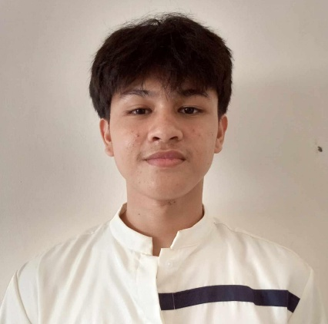**JAYRON R. RAVAGO**

**Malubago Sipocot, Camarines Sur**

[**ravagojayron6@gmail.com**](mailto:ravagojayron6@gmail.com)

**_______________________________________________________________________**

**PERSONAL DETAILS**

**Date of birth:** October 21, 2006 **Height:** 5’10

**Age:** 18 **Civil Status:** Single

**Citizenship:** Filipino **Religion:** Roman Catholic

**Gender:** Male

**EDUCATIONAL BACKGROUND**

**Secondary**

Senior High School (2024 present)

King Thomas Learning Academy Inc.

Malubago, Sipocot, Camarines Sur

Sipocot National High School (2019-2022)

Tara, Sipocot, Camarines Sur

**Elementary**

Sipocot North Central School (2013-2018)

Impig, Sipocot, Camarines Sur

**IAN B. PALENZUELA**

**San Juan Ave. Sipocot, Camarines Sur**

[**Ianpalenzuela09@gmail.com**](mailto:Ianpalenzuela09@gmail.com)

**+63469784461**

**_______________________________________________________________________**

**PERSONAL DETAILS**

**Date of birth:** September 5, 2004 **Height:** 5’6

**Age:** 20 **Civil Status:** Single

**Citizenship:** Filipino **Religion:** Roman Catholic

**Gender:** Male

**EDUCATIONAL BACKGROUND**

**Secondary**

Senior High School (2024 present)

King Thomas Learning Academy Inc.

Malubago, Sipocot, Camarines Sur

Sipocot National High School (2019-2022)

Tara, Sipocot, Camarines Sur

**Elementary**

Sipocot North Central School (2013-2018)

Impig, Sipocot, Camarines Sur

**KATE ANN P. PEREJA**

**Zone 4, Impig, Sipocot, Camarines Sur**

[**Kateannpereja517@gmail.com**](mailto:Kateannpereja517@gmail.com)

**+63810585345**

**_______________________________________________________________________**

**PERSONAL DETAILS**

**Date of birth:** August 12, 2007  **Height:** 5’5

**Age:** 17 **Civil Status:** Single

**Citizenship:** Filipino **Religion:** Roman Catholic

**Gender:** Female

**EDUCATIONAL BACKGROUND**

**Secondary**

Senior High School (2024 present)

King Thomas Learning Academy Inc.

Malubago, Sipocot, Camarines Sur

Sipocot National High School (2019-2022)

Tara, Sipocot, Camarines Sur

**Elementary**

Sipocot North Central School (2013-2018)

Impig, Sipocot, Camarines Sur